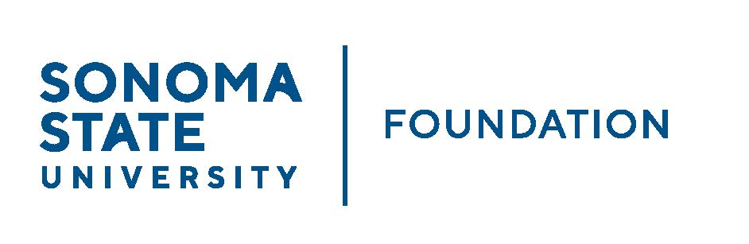
Board of Directors Meeting
Friday September 22, 2023
10 am - 12 pm
In-Person: Sonoma Valley Room, Second Floor Student Center or via Zoom
(for dial-in instructions please email alicia.hodenfield@sonoma.edu)
Lunch to follow for those attending in person
AGENDA

- 10 am – Call to Order
- Board/Committee membership changes

- Public Comment Period
- Pursuant to California Education Code 89920-28, this time is for any member of the public to address the Board on any item affecting higher education. Each speaker will be allowed no more than three (3) minutes to address the Board, total max of 10 mins.

- Consent Agenda
- June 16, 2023 Board Minutes
- Graystone Quarterly Performance Report
- Investment Pools Sheet as of 6/30/23
- CSURMA/AORMA Insurance Certificate of Coverage

- University President’s Report
- University Update

- Annual Conflict of Interest / Non-Profit Integrity Act Annual Presentation – Jeremy Olsan @ 11 am

- Committee Reports
- Executive Committee Report
- Philanthropy Committee Report
- Governance Committee Report
- Investment Committee Report
- Audit Committee Report

- Action Items
- 22/23 Audited Financial Statements and audit report (AC folder) – Andy Maffia, Aldrich
- 23/24 Revised Operating Budget
- Revised Student Managed Investment Fund Charter

- Student Update

- Alumni Association Update

- University Advancement Report

- New Business / Announcements / Adjournment
Next Meeting Date: December 1, 2023

