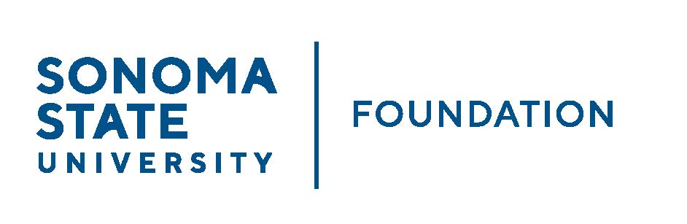

Board of Directors Meeting
Friday September 17, 2021
12:30 – 2:30 pm
Video/Teleconference Meeting
(for dial-in instructions please email kyle.bishop-gabriel@sonoma.edu)

AGENDA

12:30 pm – Call to Order
- New Board Director confirmations

Public Comment Period
- Pursuant to California Education Code 89920-28, this time is for any member of the public to address the Board on any item affecting higher education. Each speaker will be allowed no more than three (3) minutes to address the Board, total max of 10 mins.

Consent Agenda
  - June 11, 2021 Board Minutes
  - Graystone Quarterly Performance Report
  - Investment Pools Sheet as of 6/30/21
  - CSURMA/AORMA Insurance Certificate of Coverage

University President’s Report
- University Update

Conflict of Interest / Non-Profit Integrity Act Annual Presentation (Jeremy Olsan)

Committee Reports
- Executive Committee Report
- Joint Philanthropy & Governance Committee Report
- Investment Committee Report
- Audit Committee Report

Action Items
  - 20/21 Audited Financial Statements and audit report
  - SSU Foundation Investment Policy - revised

University Advancement Report
  - FY 20/21 Year End Advancement Report
  - FY 20/21 & Three Year Historical Philanthropic Summary Report
  - Goal Sheet vs. Actuals – Three Year Historical

Student Update

Alumni Association Update

New Business / Announcements / Adjournment

Next Meeting Date:
December 3, 2021 12:30 – 2:30 pm meeting

