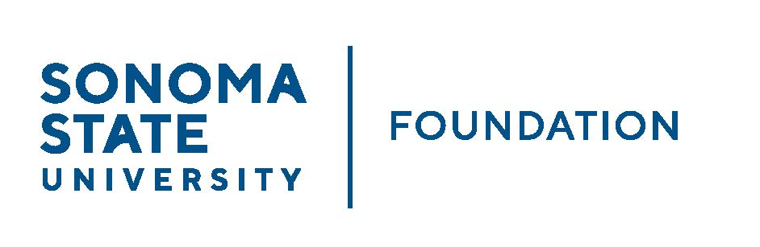

AUDIT COMMITTEE AGENDA

SSU Foundation Audit Committee
September 12, 2023
Video/Teleconference
(for dial-in instructions please email hodenfie@sonoma.edu)
1:30 -2:30pm

Members: Randy Pennington (Chair), Anita Christmas,
Mike Sullivan, Brigitte Lahme, Josh Goff

Committee Staff: Mario Perez, Amanda Visser, Ian Hannah,
Monir Ahmed, Alicia Hodenfield

Guests: Andy Maffia - Aldrich

OPENING COMMENTS

APPROVAL OF THE MINUTES – 5.4.23

22/23 AUDIT REPORT - ALDRICH

ACCEPTANCE OF FINANCIAL STATEMENTS

EXECUTIVE SESSION

OPEN ITEMS

