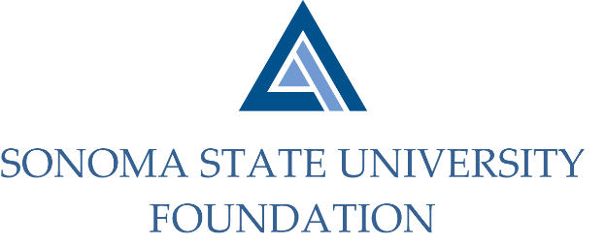

AUDIT COMMITTEE MINUTES

September 10, 2020
Video/Teleconference
2 -3pm

Members Present: Randy Pennington (Chair), Anita Christmas, Jeannette Anglin

Committee Staff Present: Amanda Visser, Ian Hannah, Joyce Lopes, Mario A. Perez, Kyle Bishop-Gabriel, Christina Shoptaugh

Guests Present: Bobby LaCour, Jennifer Dale – Aldrich

OPENING COMMENTS

Meeting opened at 2:03pm.

Pennington welcomed all to the meeting.

APPROVAL OF THE MINUTES – 5.6.20
(see 9.10.20 meeting packet)

Action: Committee unanimously approved 5.6.20 Audit Committee meeting minutes.

19/20 AUDIT REPORT- Aldrich
(see 9.10.20 meeting packet)

LaCour began review of letter to Audit Committee and noted that there were no major issues to report or discuss and no significant changes in reporting standards for the past fiscal year.

LaCour mentioned the biggest challenge was determining how to conduct audit remotely and due to good daily communication with management and a bit more
effort than conducting the audit on site, the audit was successfully completed within the planned timeframe.

LaCour proceeded to give a high level review of the audited financial statements. Committee had a few follow up questions which were answered satisfactorily by LaCour.

EXECUTIVE SESSION

Staff were removed from virtual meeting to separate break-out room to allow for Committee discussion with Aldrich.

After staff returned, Pennington called for approval of Aldrich’s Audit of the 19/20 Financial Statements.

Action: Committee unanimously approved of Audited 19/20 Financial Statements and recommends to Board for final approval.

AUDIT COMMITTEE CHARTER REVIEW
(see 9.10.20 meeting packet)

Pennington asked committee for any feedback in the review of the Audit Committee Charter. Committee had no recommendations for edits or changes. Charter will remain as is for 20/21.

OPEN ITEMS

Before closing meeting, Visser mentioned to Committee that Aldrich has been providing services for 10 years to the Foundation and noted that it may be a good time to put an RFP out to review other options and pricing from other audit firms.

After discussion the Committee determined that for the current time and circumstances they would like to extend the contract with Aldrich for another year and then re-assess after next audit to go out for RFP.

Visser also inquired with Committee members who would be interested in receiving paper copies of the Audited Financial Statements. Visser made note of those who would like a copy to be sent to them.

Meeting closed at 3:13pm.

Kyle Bishop-Gabriel – Redacted Signature
Ian Hannah – Redacted Signature

___________________________ ______________________
Minutes approved by: Minutes prepared by:
Ian Hannah Kyle Bishop-Gabriel
Chief Operating Officer and Secretary, Staff, SSU Foundation
SSU Foundation

