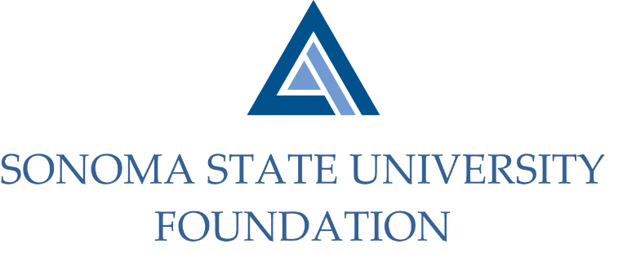

Executive Committee Session of the Board of Directors
September 9, 2020
3:00 – 4:00 pm
Video/Teleconference Meeting
(for dial-in instructions please email kyle.bishop-gabriel@sonoma.edu)

A G E N D A

Call to Order and Approval of Minutes

Review of September 18th SSU Foundation Board Meeting Agenda

Future Special Presentation Topics

Donor Confidentiality Policy

Board Best Practices Considerations

Open Items

