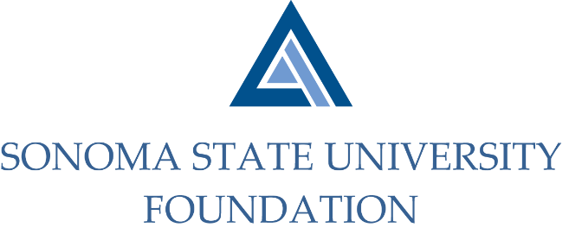

Board of Directors Meeting
Friday September 18, 2020
12:30 – 2:30 pm
Video/Teleconference Meeting
(for dial-in instructions please email kyle.bishop-gabriel@sonoma.edu)

AGENDA

12:30 pm – Call to Order
- New Board Director confirmations

Public Comment Period
- Pursuant to California Education Code 89920-28, this time is for any member of the public to address the Board on any item affecting higher education. Each speaker will be allowed no more than three (3) minutes to address the Board, total max of 10 mins.

Consent Agenda
- June 5, 2020 Board Minutes
- Graystone Quarterly Performance Report

University President’s Report
- University Update

Introduction of Provost and Academic Deans

Conflict of Interest / Non Profit Integrity Act Annual Presentation 1:30pm TIME CERTAIN

Committee Reports
- Governance Committee Report
- Philanthropy Committee Report
- Investment Committee Report
- Audit Committee Report
- Executive Committee Report

Action Items
- 19/20 Audited Financial Statements and audit report

University Advancement Report
- FY 19/20 Philanthropic Summary Report

Student Update

Alumni Association Update

New Business / Announcements / Adjournment

Next Meeting Date:
December 4, 2020 12:30 – 2:30 pm meeting

