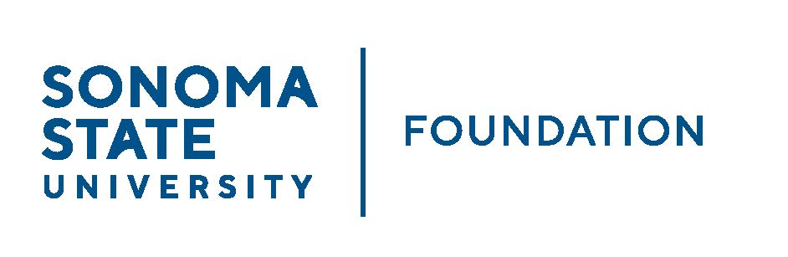

INVESTMENT COMMITTEE MINUTES

Wednesday August 11, 2021
2:00 - 4:00 p.m.
Video/Teleconference Meeting

Members Present: Ian Hannah (Chair), Mario Perez, Amanda Visser,Tom Gillespie, Brent Thomas

Committee Staff Present: Kyle Bishop-Gabriel

Guests Present: Doug Jordan Irv Rothenberg
Todd Au, Tony Parmisano, Drew Aviles, Kyle O’Keefe – Graystone Consulting
Daniel Pantucci, Andrea Ratoza – Merrill Lynch

Members Absent: Stan Nosek, Michael Troy, Terry Atkinson

OPENING COMMENTS
(see 8.11.21 meeting packet)

Meeting opened at 2pm.

Ian Hannah welcomed members and guests and reviewed the following Investment Committee member changes:
- Doug Jordan was introduced as candidate for new community Committee member. Jordan’s bio and nomination form were given to committee for review. Jordan’s Committee membership will be voted on at the upcoming September Board meeting.
- Michael Troy informed staff that he would be stepping down from Committee. Although not in attendance, Hannah thanked Troy for his time and service.
- With Michael Sullivan out on leave of absence, the Committee Co-Chair role became vacant and staff determined appointing a new Committee Chair would be in the Committee’s best interest. Hannah announced that long-term Committee member, Brent Thomas agreed to be the new full Chair for the Investment Committee. Thomas new role will be voted on at the upcoming September Board meeting.

Hannah also informed Committee of the phasing in new of the new branding and logo for the SSU Foundation. The University completed its branding study and has adopted a new look and feel including a new University Logo that will be used campus wide with all related divisions/departments/units included.

Mario Perez picked up reporting to update Committee on the latest happenings on campus including campus repopulation for students/staff/faculty along with the hiring of a new Communications Director in Strategic Communications. He noted the following:

- Campus repopulation is being worked on to slowly and safely move employees back to campus – beginning with a hybrid schedule for most.
- Occupancy for student dorms at approx. 60%, up from last year. Enrollment continues to be a work in progress and continued strategic work is being done to increase enrollment including recruitment scholarships for new students that would be multi-year to attract and keep students at SSU.
- Strategic Communications recently hired a new Communications Director to start pushing out impact stories and connect information with outside press and community and improve marketing of the University.

Perez noted that the overall feeling on campus is optimistic and hopeful as students start returning to campus.

APPROVAL OF THE MINUTES
(see 8.11.21 meeting packet)

Action: Committee unanimously approved.

CSU INVESTMENT COMMITTEE UPDATE
(see 8.11.21 meeting packet)

Hannah introduced guest and Foundation Board member Irv Rothenberg. Rothenberg currently serves as a member of the CSU Investment Committee and agreed to attend SSUF Investment Committee meeting to review what CSU stance is on fossil fuel divestment as it is currently under review.

Rothenberg began with informing Committee on why the CSU created an Investment Committee. He noted due to pressures from state legislature, the CSU brought in professionals from their system and other Board to create their Investment Committee for guidance on the investment portfolios for the system.

Rothenberg shared that with current climate change concerns and movement in activism from students and faculty to eliminate fossil fuels from CSU’s investment portfolios has brought upon a deeper look into sustainable or ESG investing.

ESG investment returns are comparable if not better than investing in managers that invest in companies that support the production and sale of fossil fuels. The Committee is considering the benefits ESG investing can provide and are working out strategies to deploy those benefits to the University system.

Rothenberg explained that the Committee is working to potentially exclude/remove current investment in companies that invest in fossil fuels and invest into those that encourage investment in tactics to alternatives that will help combat climate change.

The CSU Investment Committee determined four potential directions/options for action. The Committee and staff will do research to help decide at the next meeting October. Options to be considered are:
- Maintain current strategy – use managers to guide and decide
- Significant but not total elimination of investment in fossil fuels – about a 2% reduction out of the total 3% fossil fuel exposure
- Significant reduction of fossil fuel exposure and seek asset managers that are focusing on limited fossil fuel exposure or an ESG lens for mostly equity positions
- Complete elimination of fossil fuel exposure

Committee had free discussion with Rothenberg regarding approaches on reducing SSUF’s fossil fuel investments.

Hannah shared current SSUF Sustainable Investing Position Statement with committee. He noted it has more of an ESG focus promoting positive screening in identifying companies that are doing positive things in the ESG space. Will likely bring back this item for committee review once official stance is determined by CSU Investment Committee.

INVESTMENT POLICY STATEMENT REVISIONS
(see 8.11.21 meeting packet)

Hannah reviewed updates and changes recently made in Investment Policy Statement (IPS) with committee. He noted that the IPS needs periodic review and there are recommended revisions by Graystone and SSUF management.

Hannah reviewed all recommended updates/changes in IPS with Committee. Committee had minor questions that were answered by staff and Graystone.

Action: Committee unanimously agreed to changes and recommended the revised IPS to Board for final approval.

GRAYSTONE – POOLED ENDOWMENT INVESTMENTS
(see 8.11.21 meeting packet)

Tony Parmisano gave high level brief review of capital markets with Committee. He noted market has been bullish coming out of the pandemic and surprisingly continues to remain strong.

Parmisano reported Endowment performance for fiscal year as of 6.30.21 with a 28% return and an annual return since inception (1.1.11) of 6.5%. This compares to a long-term return objective of 6.5-7.0% annually. He noted currently the Endowment is outperforming the benchmarks.

Overall, Graystone feels very good on current state of Endowment returns.

Todd Au continued report to Committee with upcoming fund/manager changes in private equity. Au reminded Committee that as the OCIO, Graystone is able to make such changes without review and approval from the Committee but per IPS will review when making changes and investing in illiquid funds.

Au reviewed details of the following fund manager changes individually. The noted fund manager changes are to move the Endowment portfolio closer to the target for private equity exposure. He reviewed the following fund managers:

- HarbourVest Co-Investment Fund VI, is a diversified PE but not as expensive as a fund-of-fundsa vehicle. Has gone through contract review and SSU has agreed to HarbourVest contract.
- Bridge Workforce & Affordable Housing Fund, side letter created and SSU is reviewing now. Considered an impact/responsible investing strategy.

Committee had no questions and agreed to fund manager changes.
Au continued with a brief review of the Foundation’s asset allocation study compared to NTSE peer group. He highlighted that compared against peers, the Foundation is meeting benchmarks outlined in its IPS. Currently the portfolio has a higher hypothetical return and lower risk profile compared to peers.

TOWNHOMES UPDATE
(see 8.11.21 meeting packet)

In essence of time, Hannah quickly gave committee update on sales of townhomes. All but one, have been sold. Net sale proceeds support the endowment and will be invested per the IPS.

GALBREATH ENDOWMENT INVESTMENTS QUARTERLY/ANNUAL
(see 8.21.11 meeting packet)

Daniel Pantucci reviewed Galbreath portfolio with committee. Portfolio had a 4.9%% return for the latest quarter.

Pantucci noted that at this time, they are not recommending any changes to the portfolio. He noted if the portfolio market value were larger he would recommended further diversification into hedge funds from low yielding fixed income funds but that option is not currently available with the current portfolio size. He also shared that over the past year introduced an ESG investment - return on that investment has been very good. Andrea Ratoza gave a broader report on what is currently being seen with ESG investments.

INVESTMENT POOLS SHEET
(see 8.21.11 meeting packet)

In essence of time, Hannah did a high-level brief review of the investment pools sheet and noted that the SSUF balances are in line with funds pools (Cash; Endowment; Special Investments) as outlined in the IPS.

He noted the total Endowment market value was $64.5M as of 6.303.21 ($58.7M of this pooled and managed by Graystone). Total will be used for 2021 NACUBO Endowment Study of Endowments.

OPEN ITEMS

Meeting adjourned at 4:02pm.
Kyle Bishop-Gabriel – Redacted Signature
Ian Hannah – Redacted Signature
________________________ _____________________
Minutes Approved by: Minutes Prepared by:
Ian Hannah Kyle Bishop-Gabriel
Chief Operating Officer & Sr. Advancement / Secretary, SSUF Foundation Analyst, SSU

