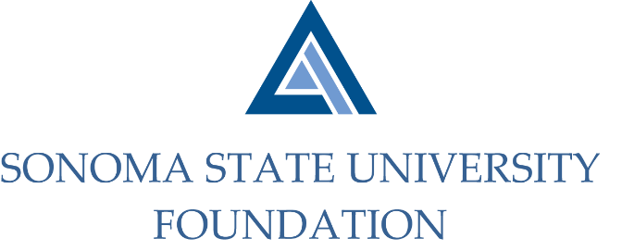
Board of Directors Meeting
Friday June 11, 2021
12:30 – 2:30p.m.
Video/Teleconference
(for dial-in instructions please email kyle.bishop-gabriel@sonoma.edu)

ANNUAL MEETING AGENDA

12:30 pm – Call to Order

Approval/Confirmation of Board of Directors and Committee membership appointments for FY 2021/2022
- Membership List
- Vote - New Board & Committee Members

Adjournment to Regular Meeting

QUARTERLY BOARD MEETING AGENDA

Call to Order

Public Comment Period
- Pursuant to California Education Code 89920-28, this time is for any member of the public to address the Board on any item affecting higher education. Each speaker will be allowed no more than three (3) minutes to address the Board, total max of 10 mins.

Consent Agenda
- March 19, 2021 Board Minutes
- Quarterly Financial Statement
- Graystone Quarterly Performance Report

University Update

Committee Reports
- Executive Committee Report
- Audit Committee Report
- Combined Philanthropy & Governance Committee Report
- Investment Committee Report

Action Items
    - Fall 2021 Pooled Endowment Distribution
    - 2021/22 SSUF Operating Budget
    - Foundation Operating Reserve Policy
    - SSUF Bylaws Revision

University Advancement Report
- Quarterly Philanthropic Summary Report

Special Presentation
    - University Advancement Strategic Direction

Student Update

Alumni Association Update

New Business / Announcements / Adjournment

Next Meeting Date:
September 17, 2021 12:30 – 2:30 pm

