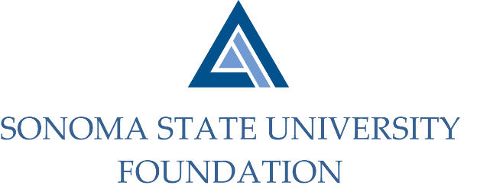

AUDIT COMMITTEE MINUTES

Wednesday, May 6, 2020
Video/Teleconference Meeting
2:00 p.m. – 3:00 p.m.

Members Present: Randy Pennington (Chair), Herm Benedetti, Sam Brown, Anita Christmas,
Jeannette Anglin

Committee Staff Present: Amanda Visser, Ian Hannah, Mario A. Perez, Kyle Bishop-Gabriel,
Christina Shoptaugh

Guests Present: Bobby LaCour, Jennifer Dale, Jonathan Hu – Aldrich

OPENING COMMENTS

Pennington opened meeting at 2:02pm and welcomed all to the meeting.

APPROVAL OF THE MINUTES – SEPTEMBER 11, 2019
(see 5.6.20 meeting packet)

Pennington asked Committee if anyone had any questions or edits to make to the draft minutes. No edits or changes were requested by Committee.

Action: Committee unanimously approved 9.11.19 minutes.

AUDIT PLAN & TIMELINE FOR 19/20 FISCAL YEAR- Aldrich
(see 5.6.20 meeting packet)

LaCour went over the planning letter for the 19/20 Fiscal Year financial audit with the committee.

He reviewed the following areas:
- Scope of Services
- Client Service Team
- Service Timeline

Interim fieldwork to begin June 15-17, 2020 and will be conducted remotely
Completion of fieldwork the week of August 3, 2020 – unsure what mode will be used to complete but could be limited on-site and rest done remotely.
- Significant Audit Areas and Issues
- Fraud Considerations
- Peer Review
- Professional and Regulatory Changes – including concerns around Cybersecurity and COVID-19 impact on Nonprofits.
- New GASB Pronouncements – no current prediction of any new announcements that will have dramatic impacts.

Aldrich are up for their peer review year and will share results once completed with Committee.

COMPLIANCE REVIEW REPORT
(see 5.6.20 meeting packet)

Visser reviewed the latest Scholarship Compliance Review Report for FY 18/19 completed January 24, 2020.

Review was done on 25 randomly selected individual endowment funds that support scholarship programs.

The review was successful and had only a few that were brought to attention for further analyses. Those few were not in error but were not distributed for logical reasons (no distribution due to lack of insufficient funds, lack of qualified applicants, and awarded but not distributed due to non-attendance of student).

Christmas joined in final review of the report as a member of the Foundation Audit Committee before finalizing.

OPEN ITEMS

Meeting adjourned at 2:35pm.
Kyle Bisho-Gabriel – Signature Redacted
Ian Hannah – Signature Redacted

___________________________ ______________________
Minutes approved by: Minutes prepared by:
Ian Hannah Kyle Bishop-Gabriel
Chief Operating Officer and Secretary, Staff, SSU Foundation
SSU Foundation

