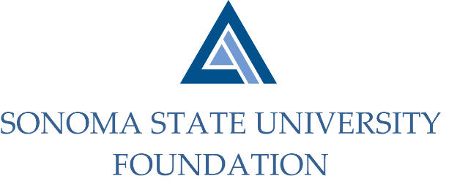

AUDIT COMMITTEE AGENDA

SSU Foundation Audit Committee Agenda
Wednesday, May 6, 2020
Video/Teleconference Meeting
(For dial-in instructions please email kyle.bishop-gabriel@sonoma.edu)
2:00 p.m. – 3:00 p.m.

Members: Randy Pennington (Chair), Herm Benedetti, Sam Brown,
Anita Christmas, Jeannette Anglin

Committee Staff: Amanda Visser, Ian Hannah, Joyce Lopes, Mario A. Perez, Kyle Bishop-Gabriel, Christina Shoptaugh

Guests: Bobby LaCour, Jennifer Dale – Aldrich

- OPENING COMMENTS

- APPROVAL OF THE MINUTES – SEPTEMBER 11, 2019

- AUDIT PLAN & TIMELINE FOR 19/20 FISCAL YEAR- Aldrich

- COMPLIANCE REVIEW REPORT

- OPEN ITEMS

