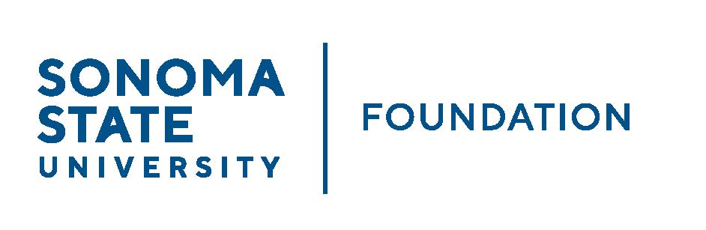

AUDIT COMMITTEE AGENDA

SSU Foundation Audit Committee Meeting
May 4, 2023
3:00-4:00pm
Location: Salazar 2043B or via Zoom
(for dial-in instructions please email bishopk@sonoma.edu)

Members: Randy Pennington (Chair), Anita Christmas, Mike Sullivan, Brigitte Lahme, Josh Goff

Committee Staff: Amanda Visser, Ian Hannah, Monir Ahmed, Mario Perez, Kyle Bishop-Gabriel, River Christina Cullen

OPENING COMMENTS

APPROVAL OF THE MINUTES – 9.14.22

AUDIT PLAN & TIMELINE FOR 22/23 FISCAL YEAR – Aldrich

CHANCELLOR’S OFFICE SSUF AUDIT UPDATE

AUDIT COMMITTEE CHARTER REVIEW

OPEN ITEMS

