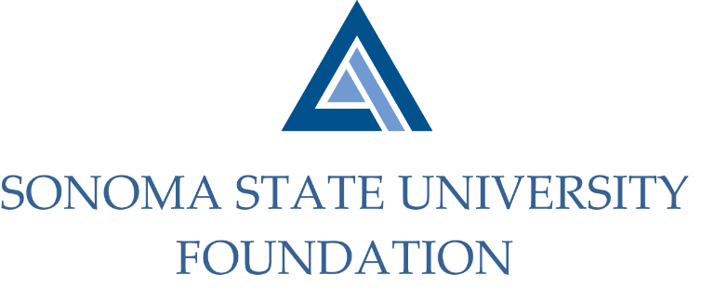

Executive Committee Session of the Board of Directors
Tuesday May 26, 2020
3:00-4:00pm
Video/Teleconference Meeting
(for dial-in instructions please email kyle.bishop-gabriel@sonoma.edu)

AGENDA

Call to Order and Approval of Minutes

Foundation Strategic Plan Updates

Scheduling of Philanthropy Committee

Revised Bylaws

Review of June 5th SSU Foundation Board Meeting Agenda
  - Special presentation topic

Open Items

