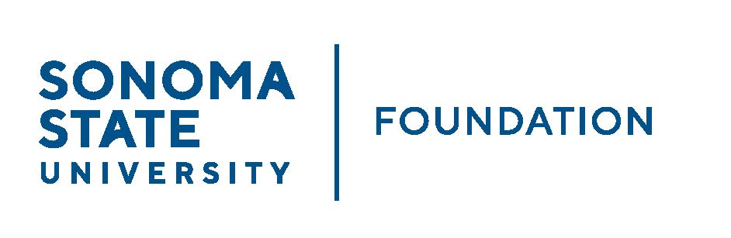

INVESTMENT COMMITTEE AGENDA

SSU Foundation Investment Committee
Tuesday May 16, 2023
2:30 - 4:30 p.m.
Location: Salazar 2043B or Zoom
(for dial-in instructions please email bishopk@sonoma.edu)

Members: Brent Thomas (Chair), Ian Hannah, Mario A. Perez,
Amanda Visser, Monir Ahmed, Tom Gillespie, Terry Atkinson, Mike Sullivan, Doug Jordan

Committee Staff: Kyle Bishop-Gabriel, River Christina Cullen

Guests: Todd Au, Tony Parmisano, Drew Aviles – Graystone Consulting

OPENING COMMENTS

APPROVAL OF THE MINUTES
  - 2.13.23 Meeting Minutes

GRAYSTONE – POOLED ENDOWMENT INVESTMENTS
  - Quarterly Update
  - NACUBO Endowment Study Results
  - Asset Allocation Study

GALBREATH ENDOWMENT INVESTMENTS QUARTERLY REPORT

2023/24 POOLED ENDOWMENT DISTRIBUTION

2023/24 SSUF OPERATING BUDGET

OPEN ITEMS

