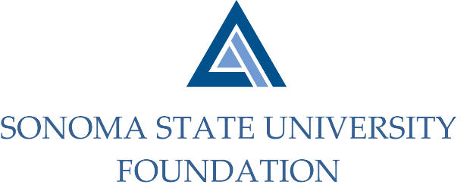

AUDIT COMMITTEE MINUTES

Monday May 10, 2021
2:00 -3:00pm
Video/Teleconference Meeting

Members Present: Randy Pennington (Chair), Anita Christmas, Jeannette Anglin

Committee Staff Present: Amanda Visser, Ian Hannah, Mario A. Perez,
Kyle Bishop-Gabriel, Christina Shoptaugh

Guests Present: Bobby LaCour - Aldrich

Opening Comments

Randy Pennington opened meeting at 2:01pm and welcomed all in attendance.

Approval of Minutes – 9.10.20
(see 5.10.21 meeting packet)

Pennington asked Committee if there were any edit requests after reviewing the draft minutes. Committee had no edits.

Action: Committee unanimously approved 9.10.20 minutes.

Audit Plan & Timeline for 20/21 Fiscal Year - Aldrich
(see 5.10.21 meeting packet)

Bobby LaCour began with a brief review of Aldrich’s engagement letter to the Committee and Management of SSUF and proceeded into the review of the following:

- Scope of Services including planned scope, timing of audit, and other.
- Client Service Team noted staff changes for this year.
- Service Timeline – planning and interim fieldwork beginning June 7th – 11th and completing fieldwork August 2nd.
- Significant Audit Areas and Issues – noting they will incorporate new and different review strategies than the previous year.
- Fraud Considerations and Peer Review report.
- Professional and Regulatory Changes – noting upcoming standards changes including the opinion section being presented first and review of online donations.

Compliance Review Report
(see 5.10.21 meeting packet)

Amanda Visser reviewed with Committee the reason behind the annual Scholarship Compliance review which is to take a sample of the endowed scholarships and verify that distributions and expenditures are in line with donor intent.

Visser noted that after the review it was verified that no errors were made in the distribution of funds and were in alignment with donor intent.

Anita Christmas was invited to give a review of the report before finalizing. Visser noted that Christmas inquired how the scholarship funds were selected and suggested a process adjustment to be sure it included some of the larger endowed scholarships as part of the annual review. Staff agreed and made note of the suggestion for future reviews.

Audit Committee Charter Review
(see 5.10.21 meeting packet)

Pennington inquired with Committee if they had any questions or suggested edits after reviewing the Committee Charter. Committee had no recommendations for change.

Pennington did note that it is desirable to appoint a member from the Investment Committee to also be a part of Audit Committee. Pennington has reached out to several of Board/Investment Committee members but has not received a volunteer yet. Staff made note to assist in finding a member who would be willing to serve.

Open Items

Before concluding meeting, Perez updated Committee on some changes on campus. He noted that Joyce Lopes, VP for Administration and Finance and campus CFO has taken a new position at Western Washington University and will conclude her time at the end of May. Mr. Stan Nosek will be returning to campus to fill the role as Interim until a new VP is recruited and appointed.

Lastly, Visser noted that this will be the Foundation’s 11th year working with Aldrich and noted that last meeting the Committee had talked of making a possible change. Committee discussed with LaCour staying with Aldrich but changing the lead/partner of overseeing the audit within the company. LaCour said it wouldn’t be an issue to rotate the leadership for the client service team.

Meeting adjourned at 2:47pm.

Kyle Bishop-Gabriel – Redacted Signature
Ian Hannah – Redacted Signature
___________________________ ______________________
Minutes approved by: Minutes prepared by:
Ian Hannah Kyle Bishop-Gabriel
Chief Operating Officer and Secretary, Sr. Advancement/Foundation
SSU Foundation Analyst & Asst. to VP, SSU

