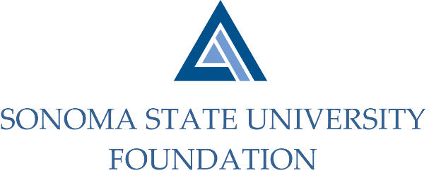

AUDIT COMMITTEE AGENDA

SSU Foundation Audit Committee Meeting
May 10, 2021
2 -3pm
Video/Teleconference
(for dial-in instructions please email kyle.bishop-gabriel@sonoma.edu)

Members: Randy Pennington (Chair), Anita Christmas, Jeannette Anglin

Committee Staff: Amanda Visser, Ian Hannah, Joyce Lopes, Mario A. Perez, Kyle Bishop-Gabriel, Christina Shoptaugh

OPENING COMMENTS

APPROVAL OF THE MINUTES – 9.10.20

AUDIT PLAN & TIMELINE FOR 20/21 FISCAL YEAR – Aldrich

COMPLIANCE REVIEW REPORT

AUDIT COMMITTEE CHARTER REVIEW

OPEN ITEMS

