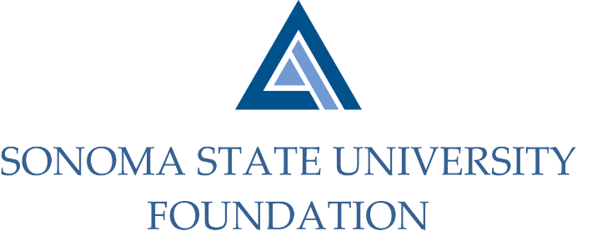

INVESTMENT COMMITTEE AGENDA

SSU Foundation Investment Committee Agenda
Wednesday April 29, 2020
Video/Teleconference Meeting
(for dial-in instructions please email kyle.bishop-gabriel@sonoma.edu)
2:30 - 4:30 p.m.

Members: Ian Hannah (Co-Chair), Michael Sullivan (Co-Chair),
Mario Perez, Amanda Visser, Joyce Lopes, Tom Gillespie, Michael Troy, Brent Thomas, Terry Atkinson

Committee Staff: Kyle Bishop-Gabriel, Christina Shoptaugh

Guests: Todd Au, Tony Parmisano, Drew Aviles, Joanna Berg,
Jeffrey Stein – Graystone Consulting

OPENING COMMENTS

APPROVAL OF THE MINUTES
  - 1.29.20 Meeting Minutes

NACUBO-TIAA STUDY OF ENDOWMENTS 18/19 COMPARATIVE DATA

GRAYSTONE – POOLED ENDOWMENT INVESTMENTS
- Quarterly Update
- Asset allocation rebalancing to revised targets

ESG INVESTMENTS
- Graystone sustainable investing analysis (MSIQ report)
- Campus constituents inquiry of fossil fuel investment exposure

GALBREATH ENDOWMENT INVESTMENTS QUARTERLY REPORT

2020/21 SSUF OPERATING BUDGET

FALL 2020 POOLED ENDOWMENT DISTRIBUTION

TOWNHOMES PROPOSAL

OPEN ITEMS

