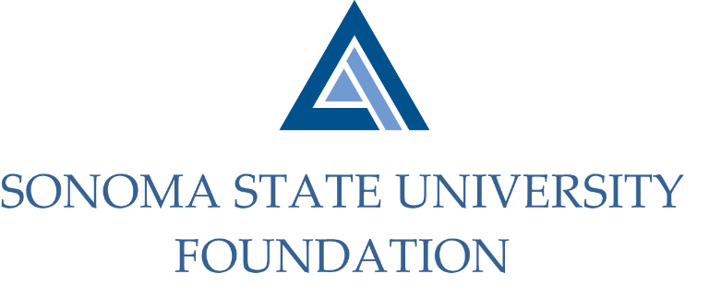

Executive Committee Session of the Board of Directors
Wednesday March 10, 2021
3:00-4:00pm
Zoom/Teleconference Meeting
(for dial-in instructions please email kyle.bishop-gabriel@sonoma.edu)

AGENDA

Call to Order and Approval of Minutes

Review of March 19th SSU Foundation Board Meeting Agenda

Future Special Presentation Topics List

Open Items

