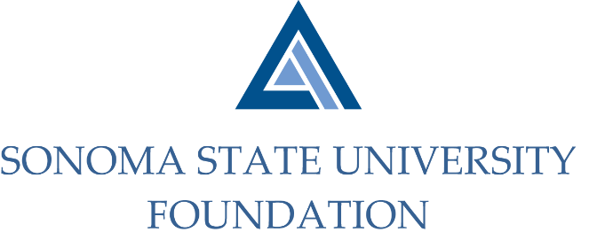
Board of Directors Meeting
Friday March 19, 2021
12:30 – 2:30p.m.
Video/Teleconference
(for dial-in instructions please email kyle.bishop-gabriel@sonoma.edu)

MEETING AGENDA

12:30pm – Call to Order

Public Comment Period
- Pursuant to California Education Code 89920-28, this time is for any member of the public to address the Board on any item affecting higher education. Each speaker will be allowed no more than three (3) minutes to address the Board, total max of 10 mins.

Consent Agenda
- December 4, 2020 Board Minutes
- Quarterly Financial Statement
- Graystone Quarterly Performance Report

University President’s Report
- University Update

Special Presentation
- SSU Foundation Endowment Investment Portfolio Overview
- 2020 NACUBO-TIAA Study of Endowments (NTSE) results comparison

Committee Reports
- Governance Committee Report
- Executive Committee Report
- Audit Committee Report
- Investment Committee Report
- Philanthropy Committee Report

Action Items
- SSUF Board of Director Statement of Understanding Revision

University Advancement Report
- CSU FY 19/20 Philanthropic Report
- Quarterly Philanthropic Summary Report

Student Update

Alumni Association Update

New Business / Announcements / Adjournment

Next Meeting Date: Friday 6/11/21

