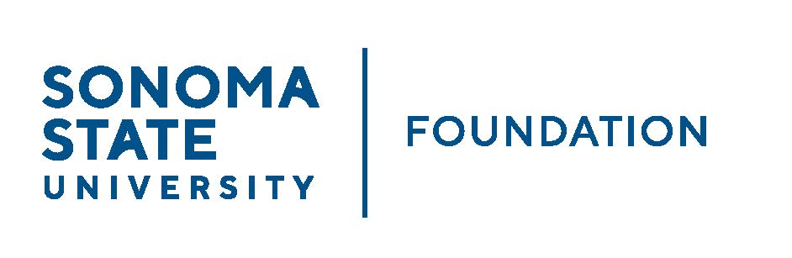

**AUDIT COMMITTEE AGENDA**

SSU Foundation Audit Committee Meeting

September 11, 2024

3:30-4:30pm

Location: Salazar 2043B or via Zoom

(For dial-in instructions please email foundation@sonoma.edu)

*Members:* Randy Pennington (Chair), Anita Christmas,

Mike Sullivan, Brigitte Lahme, Josh Goff

*Committee Staff:* Amanda Visser, Ian Hannah, Monir Ahmed,   
Mario Perez, Alicia Hodenfield, Kristin Hillman

Guest(s): Andy Maffia - Aldrich

1. OPENING COMMENTS
2. APPROVAL OF THE MINUTES – 5/9/24
3. 23/24 AUDIT REPORT – ALDRICH
4. EXECUTIVE SESSION
5. ACCEPTANCE OF FINANCIAL STATEMENTS
6. OPEN ITEMS