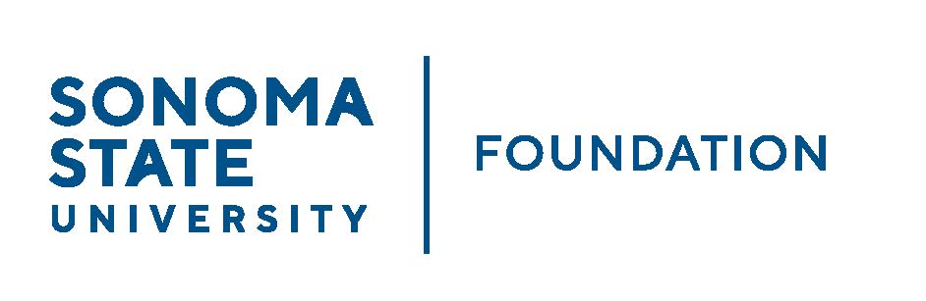

INVESTMENT COMMITTEE AGENDA

SSU Foundation Investment Committee
Tuesday October 31, 2023
2:30 - 4:30 p.m.
Location: Salazar 2043B or Zoom
(for dial-in instructions please email hodenfie@sonoma.edu)

Members: Brent Thomas (Chair), Ian Hannah, Mario A. Perez,
Amanda Visser, Monir Ahmed, Tom Gillespie, Mike Sullivan,
Doug Jordan

Committee Staff: Alicia Hodenfield

Guests: Todd Au, Tony Parmisano, Drew Aviles – Graystone Consulting

- OPENING COMMENTS

- APPROVAL OF THE MINUTES
  - 8.22.23 Meeting Minutes

- 22/23 ENDOWMENT TALKING POINTS & NACUBO-COMMONFUND STUDY OF ENDOWMENTS (NCSE) SURVEY SUBMISSION

- CSU SYSTEMWIDE INTENTIONAL ENDOWMENTS NETWORK (IEN) MEMBERSHIP

- GRAYSTONE – POOLED ENDOWMENT INVESTMENTS
  - Quarterly Update: capital markets update and portfolio review
  - Private Equity Fund Opportunities

- GALBREATH ENDOWMENT INVESTMENTS QUARTERLY REPORT

- FIDUCIARY OVERSIGHT OF INVESTMENT PROGRAM

- OPEN ITEMS

