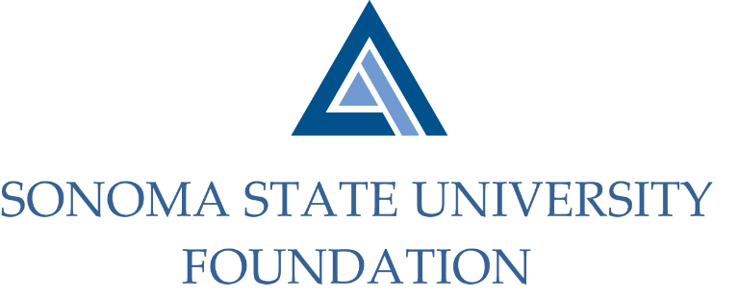

PHILANTHROPY COMMITTEE MINUTES

Thursday February 18, 2021
Zoom/Teleconference
2:00 – 3:30 p.m.

Members Present: Terry Atkinson (Chair), Robert U’Ren, Mario Perez

Committee Staff Present: Kyle Bishop-Gabriel

Members Absent: Tom Isaak, Ian Hannah

OPENING COMMENTS

Meeting opened at 2:05pm.

Mario Perez provided a campus update to Committee. He noted that the Commencement Committee decided to host a drive thru ceremony to recognize both the 2020 and 2021 Graduates to be held on successive weekends in May. He also shared that some of the typical events around Commencement will continue in a virtual format such as Alumni Engagement’s “Toast of the Town” event.

APPROVE 11.5.20 MEETING MINUTES
(see 2.18.21 meeting packet)

Action: Committee unanimously approved 11.5.20 minutes.

UNIVERSITY ADVANCEMENT PHILANTHROPIC UPDATE & PLANNING
(see 2.18.21 meeting packet)

Perez began with a high level review of the most recent Philanthropic Summary Report ending 12.30.20. He noted that SSU currently stands at 53% of it’s annual goal. Perez then transitioned to the Philanthropic Update and Planning presentation for University Advancement that was given to Cabinet earlier this month.
Perez reviewed total giving figures and gift highlights for the fiscal year to date along thru the end of January 2021. Most notable was Athletics Fundraising which has brought in ~ $70k from over 400 donations for Athletic Programs and Scholarships.

Perez shared his focus areas which include collaboration across campus units to achieve mutual goals, consistency in solicitations and donor stewardship, the ability to adapt and shift quickly to a changing environment, building relationships on and off campus and the closing of lingering gifts.

Perez closed with Advancement’s next steps which included the following:
- Address urgent need to increase private support for student scholarships.
- Collaborate with cabinet to support focus areas of Graduate Initiative 2025.
- Developing a case statement.
- Coordinate initiative with University Communications.
- Incorporate recruitment scholarships as goals for Director’s of Development.

GIVING DAY

Perez announced to Committee that SSU will be conducting it’s first annual Giving Day on April 29th. The annual event was to have it’s first kick off last year but was delayed due to the rapid changes that took place with COVID lockdowns.

Perez shared that a custom online platform is being worked on and he is hopeful it will attract existing donors along with new donors. The goal is to establish a consistent pipeline of donors and donations to SSU initiatives, programs, and scholarships.

Perez inquired with Committee about having Board collectively come up with a “challenge” for giving that coincides with the SSU Giving Day. Perez recommended possibly making the request in the following year.

Committee agreed that asking Board to participate would be beneficial to the efforts.

SSUF BOARD MEMBER GIVING MINIMUMS
(see 2.28.21 meeting packet)

Perez reviewed list of other CSU campus Foundations Board member giving requirements. The list gave insight to the degrees of variance between each CSU campus Foundation Board. After much thought and consideration, Perez recommended to the Committee to implement a $2500/year minimum giving of each Board member to start. Board members can decide what programs or initiatives they wish to donate to.

Committee discussed when the appropriate time would be to implement and whether or not it should be all existing Board members in addition to any newly inducted members. Committee generally had consensus that all members are to be subject to the $2500 annual giving.

Committee agreed to move the $2500 annual giving requirement as a recommendation to the Board for approval.

OPEN ITEMS

Before concluding meeting, Perez noted that the University has begun the search for a permanent Athletics Director.

Meeting closed at 3:16pm.

Kyle Bishop-Gabriel – Redacted Signature
Ian Hannah – Redacted Signature
__________________________ ___________________________
Minutes Approved by: Minutes Prepared by:
Ian Hannah Kyle Bishop-Gabriel
Chief Operating Officer & Sr. Advancement/Foundation Analyst, SSU
Secretary, SSUF

