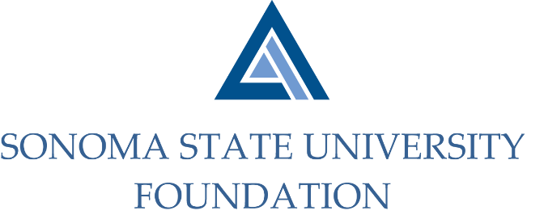
Board of Directors Meeting
Friday December 4, 2020
12:30-2:30pm
Video/Teleconference

MEETING AGENDA

12:30pm – Call to Order

Public Comment Period

Pursuant to California Education Code 89920-28, this time is for any member of the public to address the Board on any item affecting higher education. Each speaker will be allowed no more than three (3) minutes to address the Board, total max of 10 mins.

Consent Agenda

September 18, 2020 Board Minutes

Quarterly Financial Statements

19/20 Philanthropic Activity Data Summary Slides

Board Make Up Sheet

Graystone Quarterly Performance Report

19/20 NACUBO Endowment Survey Talking Points

University President’s Report

University Update

Special Presentation

Alumni Association & Annual Giving

Committee Reports

Audit Committee Report

Philanthropy Committee Report

Governance Committee Report

Investment Committee Report

Executive Committee Report

Action Items

Confidentiality Policy & Agreement

University Advancement Report

Quarterly Philanthropic Report

Student Update

New Business / Announcements / Adjournment

Next Meeting Date: Friday 3/19/21 (12:30 – 2:30pm) – Zoom/Teleconference

