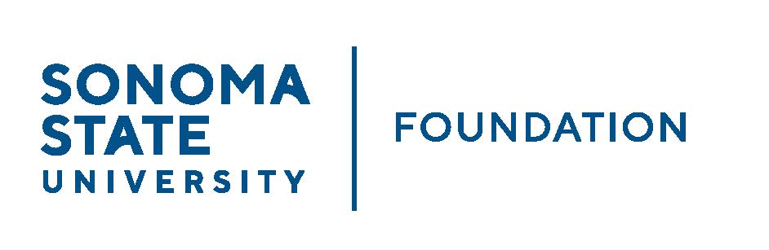

INVESTMENT COMMITTEE AGENDA

SSU Foundation Investment Committee Agenda
Wednesday November 2, 2022
2:30-4:30p.m.
Video/Teleconference Meeting
(for dial-in instructions please email bishopk@sonoma.edu)

Members: Brent Thomas (Chair), Ian Hannah, Mario A. Perez,
Amanda Visser, Monir Ahmed, Tom Gillespie,
Terry Atkinson, Mike Sullivan, Doug Jordan

Committee Staff: Kyle Bishop-Gabriel, River Christina Cullen

Guests: Todd Au, Tony Parmisano, Drew Aviles, Kyle O’Keefe – Graystone Consulting

OPENING COMMENTS

APPROVAL OF THE MINUTES
  - 8.17.22 Meeting Minutes

21/22 ENDOWMENT TALKING POINTS

GRAYSTONE – POOLED ENDOWMENT INVESTMENTS
  - Quarterly Update

GALBREATH ENDOWMENT INVESTMENTS QUARTERLY REPORT

OPEN ITEMS

