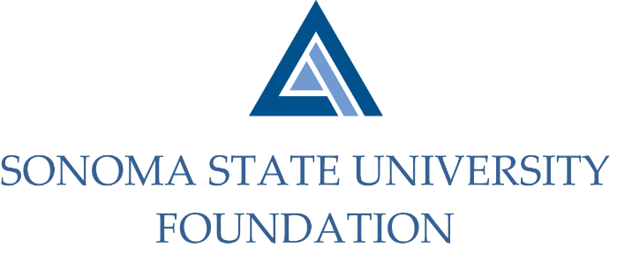

INVESTMENT COMMITTEE MINUTES

Thursday October 29th, 2020
Video/Teleconference Meeting
2:30 - 4:30 p.m.

Members Present: Ian Hannah (Co-Chair), Michael Sullivan (Co-Chair),
Mario A. Perez, Amanda Visser, Joyce Lopes, Tom Gillespie, Michael Troy, Brent Thomas

Committee Staff Present: Kyle Bishop-Gabriel, Christina Shoptaugh

Guests Present: Todd Au, Tony Parmisano, Drew Aviles, Kyle O’Keefe, Jeff Stein – Graystone Consulting

Members Absent: Terry Atkinson

OPENING COMMENTS

Hannah opened the meeting at 2:32pm.

Before moving into agenda items, Perez briefed the Committee on campus and University Advancement updates. Lopes also added that the CSU decided to continue the current remote learning environment through Spring 2021 with limited in-person classes.

APPROVAL OF THE MINUTES
(see 10.29.20 meeting packet)

Action: Committee unanimously approved 8.4.20 minutes.

NACUBO-TIAA STUDY OF ENDOWMENTS 19/20 TALKING POINTS
(see 10.29.20 meeting packet)

Hannah reviewed the NACUBO Study of Endowments 19/20 Talking Points with Committee. He noted the survey has been prepared for submission for SSU. The talking points sheet gives the highlights of information shared for the survey.

The final study results are typically released in February/March and Hannah noted that once the final results are in he will be working with Graystone to prepare a full presentation on the SSU Endowment and comparative results to present at the March Board meeting.

GRAYSTONE – POOLED ENDOWMENT INVESTMENTS
(see 10.29.20 meeting packet)

Parmisano began with a Quarterly review of the market. He highlighted it was a good quarter resulting in recovery amid recent volatility. Although economic growth has been slowed due to COVID lockdown measures, there are some signs of economic growth beginning next year.

Au continued with an update of the Foundation Endowment portfolio noting that with a strong Quarter, the portfolio outperformed with quarterly earnings at 9/30/20 at 5.82%.

He shared that the Committee made a good decision last year to make asset allocation changes, weighting the portfolio heavier in equities which helped the portfolio perform well.

GALBREATH ENDOWMENT INVESTMENTS QUARTERLY REPORT
(see 10.29.20 meeting packet)

Hannah did a quick review of the Galbreath Endowment earnings which was just over 5% this past quarter ending 9/30/20.

INVESTMENT POOLS SHEET
(see 10.29.20 meeting packet)

Hannah shared with Committee the current Investment Pool Sheet which was originally created from a CSU Audit comment awhile back. He reviewed the following items: Endowment Cash, Pooled & Non-Pooled Endowments as well as special investment pool assets such as the established Student Managed Investment Fund (SMIF) account.

The total SSUF Endowment market value of $52.7M as of 6/30/20, was the figure reported for the NACUBO Endowment Survey.

OPEN ITEMS

Visser shared with Committee that the University is reviewing their Reserves Policy across campus and the Foundation reserves will be reviewed as well.

Before closing, Hannah gave a quick update the progress for the sale of the Foundation Townhomes.

Meeting adjourned at 3:36pm.

Kyle Bishop-Gabriel, Redacted Signature
Ian Hannah, Redacted Signature
__________________________ ___________________________
Minutes Approved by: Minutes Prepared by:
Ian Hannah Kyle Bishop-Gabriel
Chief Operating Officer & Sr. Advancement/Foundation
Secretary, SSUF Analyst, SSU

