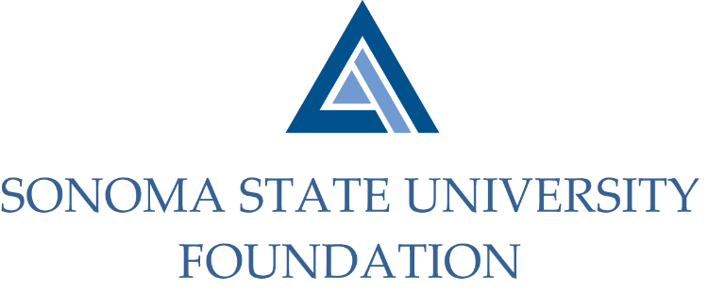

GOVERNANCE COMMITTEE MINUTES

SSU Foundation Governance Committee
Thursday October 24, 2019
Salazar Hall - Administration and Finance, Conference Room A
3:00 – 4:30 p.m.

Members Present: David Felte (Chair), Ian Hannah, Gordon McDougall,
Tom Isaak

Committee Staff Present: Kyle Bishop-Gabriel

Members Absent: Randy Pennington, Sam Brown, Terry Atkinson

OPENING COMMENTS

Meeting opened at 3:05pm.

Felte shared final and Board approved copy of Committee Charter with all in attendance which gives a broad outline of the charge of the Committee.

APPROVAL OF THE MINUTES
(see 10.24.19 meeting packet)

Action: Minutes for 8.14.19 meeting unanimously approved.

CURENT BOARD MATRIX AND PARTICIPATION
(see 10.24.19 meeting packet)

Felte directed Committee to review upcoming term renewals for 13 Board members which all have their first term end June 2020. Approximately 6 of those members have self-identified in a previous conversation a few years ago that they likely will be stepping down from the Board at that time. It was agreed that the Board Chair or Vice Chair may need to touch base with those members to see if they still would like to step down.

Committee discussed best way of reaching out to all Board members up for renewal and how to retrieve responses from each member. Committee thought it would work to have an email sent out to each member up for term renewal identifying what term they are in (1st, 2nd, or 3rd term), participation level (Committee participation), and overall attendance over recent term. This would allow members to respond and to also provide feedback on their wishes to either continue or possibly step down from the Board. Based on feedback, Board Chair or Vice-Chair could engage in a one-on-one conversation with Board members to get a better assessment of their engagement level.

Committee agreed that it would be best to send email out before the end of the year to allow Board members time to think about how they would like proceed.

Staff agreed to draft an email and a way to collect information from each Board member and will deliver for review before sending out to Board members.

POTENTIAL NEW BOARD AND COMMITTEE MEMBERS
(see 10.24.19 meeting packet)

Committee reviewed current 0-12 month timeline Board member prospects and where Advancement staff is at in terms of upcoming nominations. Advancement Director’s of Development (DOD’s) are working on reaching out to a few individuals to gauge their interest in serving on the Board. Hannah noted that the DOD’s are at various stages of contact and review with the individuals on the list.

DRAFT Philanthropy Committee Charter
(see 10.24.19 meeting packet)

Committee review a draft of the formation of a new Foundation Committee, a Philanthropy Committee. The charter reviews the main purpose and responsibilities of the Committee.

Committee discussed if Board was ready to take on the additional Committee. It was noted that presenting the charter for approval would at least get initial groundwork started for forming the Committee when the time is right to begin meetings with the Philanthropy Committee. McDougall and Hannah also shared that some Board members have already been approached to potentially serve on the Committee.

Action: Committee approves Philanthropy Committee Charter for Board approval.

BYLAWS REVIEW
(see 10.24.19 meeting packet)

Hannah provided a soft introduction to potential changes in the current Foundation Bylaws. Highlighted areas of sections impacted by changes were looked at and a deeper dive in making those changes will be coming up at future meetings.

OPEN ITEMS

Meeting closed at 4:29pm.

Kyle Bishop-Gabriel – Redacted Signature
Ian Hannah – Redacted Signature

__________________________ ___________________________
Minutes Approved by: Minutes Prepared by:
Ian Hannah Kyle Bishop-Gabriel
Chief Operating Officer & Advancement/Foundation Analyst, SSU
Secretary, SSUF

