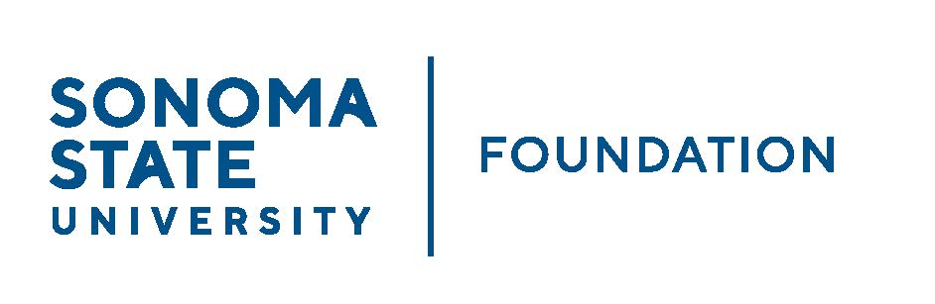

INVESTMENT COMMITTEE AGENDA

SSU Foundation Investment Committee Agenda
Wednesday October 20, 2021
2:30 - 4:30 p.m.
Video/Teleconference Meeting
(for dial-in instructions please email kyle.bishop-gabriel@sonoma.edu)

Members: Brent Thomas (Chair), Ian Hannah,
Mario A. Perez, Amanda Visser, Stan Nosek,
Tom Gillespie, Terry Atkinson, Doug Jordan

Committee Staff: Kyle Bishop-Gabriel, Christina Shoptaugh

Guests: Todd Au, Tony Parmisano, Drew Aviles – Graystone Consulting; Irv Rothenberg – CSU Investment Committee

OPENING COMMENTS

APPROVAL OF THE MINUTES
  - 8.11.21 Meeting Minutes

20/21 ENDOWMENT TALKING POINTS

CSU INVESTMENT COMMITTEE / FOSSIL FUEL DIVESTMENT UPDATE

GRAYSTONE – POOLED ENDOWMENT INVESTMENTS
  - Quarterly Update

GALBREATH ENDOWMENT INVESTMENTS QUARTERLY REPORT

SSU STUDENT MANAGED INVESTMENT FUND (SMIF) UPDATE

OPEN ITEMS

