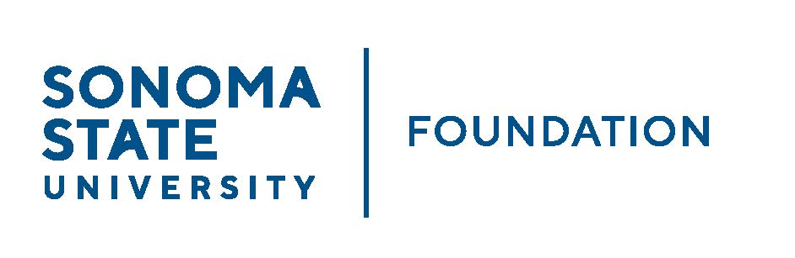

INVESTMENT COMMITTEE MINUTES

Wednesday October 20, 2021
2:30 - 4:30 p.m.
Video/Teleconference Meeting

Members Present: Brent Thomas (Chair), Ian Hannah,Mario A. Perez, Amanda Visser, Stan Nosek, Tom Gillespie, Terry Atkinson, Doug Jordan

Committee Staff Present: Kyle Bishop-Gabriel, Christina Shoptaugh

Guests Present: Todd Au, Tony Parmisano, Drew Aviles – Graystone Consulting

OPENING COMMENTS

Ian Hannah opened the meeting at 2:31pm.

He welcomed Committee member, Brent Thomas as the Committee’s new Chair as well as new community Committee member, Dr. Douglas Jordan.

Hannah provided the following notable updates to Committee:
- The Fall 2021 Endowment distribution went out in September totaling approximately $1.6M.
- A new $2.5M endowment gift was received from the Green family that will go to supporting the GMC.

Mario Perez and Stan Nosek shared briefly a couple of following campus updates with Committee:
- Nosek noted that the CSU was allowed a few years ago to invest systemwide funds for the purpose of supporting deferred maintenance needs across the system has been performing well and is working in the way it was intended, allowing disbursement of those earnings across the system to campuses in need – this year $1.2M given to SSU.
- Perez highlighted the recent Chancellor Visit on September 29th by Chancellor Joseph Castro. Perez noted there were good conversations with campus Board members in the afternoon and that Chancellor Castro enjoyed meeting and having those conversations. Perez noted that Chancellor Castro arrived not knowing much about the Sonoma State Campus but left feeling well informed. He expressed feeling very happy with the direction of the University and understood the work ahead as well as the challenges that SSU is working through.

APPROVAL OF THE MINUTES
(see 10.20.21 meeting packet)

Thomas called for approval of the 8.11.21 Investment Committee meeting minutes from Committee.

Action: Committee unanimously approved.

20/21 ENDOWMENT TALKING POINTS
(see 10.20.21 meeting packet)

Hannah informed Committee that the next annual NACUBO-TIAA STUDY OF ENDOWMENTS (NTSE) for the 20/21 year will be due next month. Staff along with help from Graystone are currently working on SSUF’s information to submit.

Hannah provided preliminary details to Committee by reviewing the 20/21 Talking Points Summary sheet. Survey questions included information for the following:
- Endowment Market Value
- Asset allocation
- Returns
- Spending
- Continued focus on responsible investing – including diversity, equity and inclusion considerations (DEI).

Hannah noted that staff will compile and share comparative data once study is finalized and released, early next year.

Committee shared feedback and suggestions to add a few extra elements to sheet. Staff made note of suggestions.

CSU INVESTMENT COMMITTEE / FOSSIL FUEL DIVESTMENT UPDATE
(see 10.20.21 meeting packet)

Thomas directed Committee to the CSU Press release regarding future fossil fuel investments. He noted there weren’t any surprises to their decision in press release to have no future investments in fossil fuels.

Hannah added that since the larger CSU system made the decision not to make any future investments in fossil fuels it is setting the tone and direction but allowing campuses to adopt an investment strategy that best fits their own specific missions.

Hannah turned attention to the SSU Socially Responsible Investing (SRI) Position Statement, reviewing the current position statement and the focus around positive screening for environmental, social and governance (ESG) practices. He noted that this approach has resulted in reduced exposure to fossil fuels rather than taking a negative screening approach toward full divestment.

Other approaches were discussed such as funneling a portion of the portfolio to green infrastructure related projects or impact investing, or diversity, equity and inclusion (DEI) considerations. Ultimately, Committee members generally showed support for the current statement as it’s a nice blend of noting that efforts are being made and keeps door open for opportunities.

SSUF management will discuss further with Graystone and bring back any proposed edits to the SRI position statement in line with direction and comments provided but it was noted to keep the same general approach.

GRAYSTONE – POOLED ENDOWMENT INVESTMENTS
(see 10.20.21 meeting packet)

Tony Parmisano reviewed Graystone’s quarterly update with the Committee. He noted that markets did slow down and flatten out a bit over the past quarter and there may be a revaluation/sell-off forthcoming. Feds will likely be looking to increase interest rates next year and it is viewed that the high inflation at the moment is likely temporary. Graystone is keeping a slightly conservative posture in the portfolio and there are no anticipated changes to managers.

Todd Au reviewed asset allocation targets as well as the returns of the endowment for the past quarter. He noted the portfolio still has a slight underweight to the public equity side and will continue to be underweight as markets work through a correction.

The quarter to date return on the portfolio was relatively flat, but given the significant volatility and market going through a rolling correction, it was overall a good quarter. Portfolio ended essentially flat for the latest quarter.

GALBREATH ENDOWMENT INVESTMENTS QUARTERLY REPORT
(see 10.20.21 meeting packet)

Thomas did a quick review of the Galbreath quarterly report. Performance was flat for last quarter with a 6.5% annualized return over last 5 years.

Hannah added he had quick phone call with Brian Bonvechio, investment manager from Merrill Lynch regarding the portfolio noting that “overall, the investment managers have performed in line with expectations which is good and they are expecting a softer next quarter in the equity markets but looking forward to a positive 2022.”

Bonvechio also stressed that ESG investing is NOT a fad that will come and go. He shared that 6.4% of Galbreath endowment investment portfolio is in an ESG fund. Merrill Lynch has the ability to run the portfolio though an ESG screen and will do so in near future for potential additional portfolio exposure in that space.

SSU STUDENT MANAGED INVESTMENT FUND (SMIF) UPDATE

Doug Jordan reviewed history of how the SSU SMIF came to fruition. He noted a former successful student, Nick Mendelson drove the idea of creating the fund and establishing a student investment group. Mendelson currently leads the group and does a majority of the work. With the help of a willing donor to provide the starting funds for the program, the SMIF account for the SSU students was established. Mendelson currently meets with the students and teaches them how to be an investment professional and how to work and act in the industry. Jordan helps recruit students who are interested to replace graduates and bring in new students every year.

Jordan expressed it has been a wonderful conduit for preparing students to be in the industry and has successfully transitioned graduating students and alumni into jobs with major financial institutions. He said it makes a real difference to work with real money and doing live investments.

The fund is open to anyone who wishes to donate additional funding.

Committee was very impressed and excited about the SMIF program and suggested sending a thank you note to Mendelson for all the work he has does with the students. Staff made note of request.

Thomas further informed committee that the corpus of the SMIF fund in TD Ameritrade currently sits at $11,875 (FY 19/20 original donations received) and market value as of 6/30/21 = $15,668. The FY 20/21 return = 33.3%

OPEN ITEMS
(see 10.20.21 meeting packet)
Hannah provided a final update on the recent townhome sales. He did a brief review of a summary sheet showing all 10 units now sold and proceeds retained by the endowment.
Meeting adjourned at 3:52pm.

Kyle Bishop-Gabriel – Redacted Signature
Ian Hannah – Redacted Signature
________________________ ___________________________
Minutes Approved by: Minutes Prepared by:
Ian Hannah Kyle Bishop-Gabriel
Chief Operating Officer & Sr. Advancement/Foundation Analyst
Secretary, SSUF & Asst. to the VP, SSU

