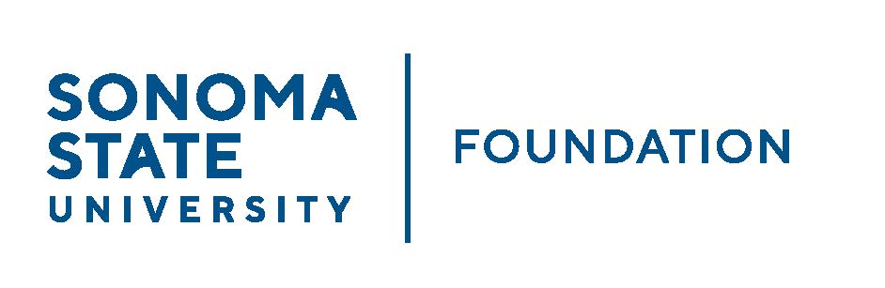

PHILANTHROPY & GOVERNANCE JOINT COMMITTEE MINUTES

Thursday September 8, 2022
Zoom/Teleconference
10:00 – 11:30AM

Members Present: Mario Perez (Joint Chair – Phil & Gov), David Felte (Gov),
Ian Hannah (Phil & Gov), Robert U’Ren (Phil)

Committee Staff Present: Kyle Bishop-Gabriel

Guests Present: Ali Pourghadir

Members Absent: Tom Isaak, Terry Atkinson

Opening Comments

Mario Perez welcomed guest Ali Pourghadir as a guest and as a potential future member of the Governance Committee. He noted that Ali would be filling the vacancy of Jeannette Anglin after stepping off the Board and Governance Committee. Pourghadir has already been recommending individuals as potential Board Members and will be a welcomed addition to the Committee.

Perez continued to share that the President Meet & Greet event from last week was very successful and gave an opportunity for volunteers from SSU’s campus Boards as well as prestigious donors to meet the new President. The President made an impression on those in attendance and his presence has brought a new energy to campus.

Perez noted that Advancement will have their first team retreat since the beginning of the pandemic and all are looking forward to team building and identifying Advancement’s vision going forward.

The campus has a lot of great energy to start off the year and it has been refreshing to have many students back on campus. Perez shared that yesterday was the annual hot dog giveaway for students and campus which was buzzing with lots of energy and hope and excitement for moving forward.
Perez answered questions from Committee about updates and President Lee. He noted that Dr. Lee is focusing on improving SSU’s budget, addressing enrollment challenges and establishing a marketing plan for the university.

Approval of Minutes
(see 9.8.22 meeting packet)

Action: Meeting minutes from 5.11.22 unanimously approved by Committee.

Philanthropic Productivity Update
(see 9.8.22 meeting packet)

Perez noted that SSU Advancement has a small Advancement team compared to other CSU campuses in our peer group and has successfully met and surpassed fundraising goals the past couple years.

FY 21/22, SSU achieved $9.5M goal with gift commitments totaling $10.0M. SSU had 1,914 individual donors, 687 of which are alumni donors. An increase of 22% and 16% respectively from the prio fiscal year.

Advancement has had a 3-year historical upward trend in fundraising even through the challenges of the past couple years. The expansion of Giving Day, moving Grad Pack purchases as donations for Lifetime Alumni memberships and improved fundraising efforts have made a substantial impact. New this year is the Parent & Family Association where donations are helping to increase number of donors and move Advancement closer to individual donor goal. Advancement tabled during move in days to sign parents/families up with a $20 donation and a benefit of a t-shirt for joining.

Perez shared Advancement’s goal for this FY (22/23) = $10M gift commitments. Advancement’s goal is to push for 2,500 individual donors and 750 alumni donors.

SSU Marketing/Advertising Update

Perez shared that marketing and advertising is a presidential focus for SSU in addition to addressing current budget and enrollment challenges. Current third parties are being looked at to take on helping to better market the university in surrounding community and beyond.

Institutional Philanthropic Priorities

Perez shared with Committee in preparation for discussion with President Lee at December Board meeting, the following current institutional philanthropic priorities under discussion:

- General Scholarships/Recruitment Scholarships have made an impact in students deciding to be at SSU. Eventually build an endowment to continue to support student recruitment and continue to support students during their time at SSU.
- Working with Deans and Cabinet on the following priorities:
- Health Sciences Initiative/Nursing Program proposal to Senator Mike McGuire and future support.
- Others include, Climate Resiliency Initiative, Small Business/Hospitality and an inclusive and thoughtful leadership center.

Perez announced that the same day of the December Board meeting, there will be a ribbon cutting for the soft opening of Stevenson Hall. Board meeting will follow the ribbon cutting as Board members will be invited to attend.

Advancement will be busy with several events for the first half of the year.

New Board Prospects/Recommendations

Perez asked Committee to recommend Pourghadir to be part of the Governance Committee, replacing Jeannette Anglin’s spot.

Action: Committee unanimously agreed to bring Pourghadir as a new Governance Committee member and recommend to Board to vote him in at the September Board meeting.

Perez noted to Committee to continue to encourage bringing forward names for potential new Board/Committee membership.

Revised SSUF Corporate Resolution - Delegation of Authority
(see 9.8.22 meeting packet)

Ian Hannah shared with committee some minor updates to the Foundation Corporate Resolution.

Hannah noted the following changes:
Remove officers who are non-campus employees as that was the intent of the resolution when first passed prior to the more recent changes of Chair and Vice Chair now being community members. Leaves day-to-day fiscal and contractual affairs of SSUF with campus employees.

Action: Committee unanimously approved recommend changes of the Foundation Corporate Resolution and recommend to Board for final approval.

Open Items

No open items. Perez reminded Committee of next Board meeting which is scheduled
for September 23rd from 2:30-4:30pm via zoom.
____________________ ___________________________
Kyle Bishop-Gabriel – Redacted Signature
Ian Hannah – Redacted Signature
Minutes Approved by: Minutes Prepared by:
Ian Hannah Kyle Bishop-Gabriel
Chief Operating Officer Sr. Advancement/Foundation Analyst &
SSUF Assistant to the VP, SSU

