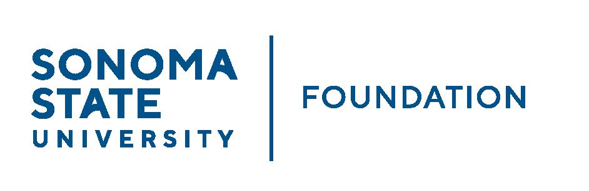

AUDIT COMMITTEE AGENDA

SSU Foundation Audit Committee
September 14, 2022
Video/Teleconference
(for dial-in instructions please email kyle.bishop-gabriel@sonoma.edu)
1:30 -2:30pm

Members: Randy Pennington (Chair), Anita Christmas,
Mike Sullivan, Brigitte Lahme

Committee Staff: Mario Perez, Amanda Visser, Ian Hannah,
Monir Ahmed, Kyle Bishop-Gabriel, River Shoptaugh

Guests: Andy Maffia - Aldrich

OPENING COMMENTS

APPROVAL OF THE MINUTES – 5.6.22

21/22 AUDIT REPORT- Aldrich

EXECUTIVE SESSION

OPEN ITEMS

