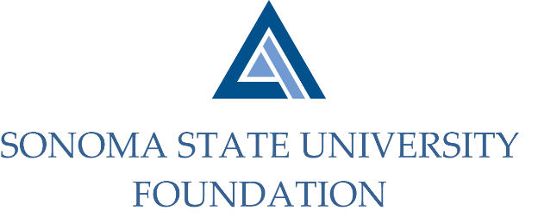

AUDIT COMMITTEE MINUTES

SSU Foundation Audit Committee
Wednesday September 11, 2019
Conference Room A – Salazar Hall
2 -3pm

Members Present: Randy Pennington (Chair), Herm Benedetti (tele.), Anita Christmas

Guests Present: Jeannette Anglin, Bobby LaCour (Aldrich, tele.), Jennifer Dale (Aldrich, tele.)

Committee Staff Present: Amanda Visser, Ian Hannah, Gordon McDougall, Kyle Bishop-Gabriel, Christina Shoptaugh

Members Absent: Sam Brown

OPENING COMMENTS

Pennington opened meeting at 2:02pm.

Pennington shared with Committee that he had met with the auditors from Aldrich about 80% through the audit.
He noted that there were no significant findings and all went smoothly.

APPROVAL OF THE MINUTES – May 22, 2019
(see 5.22.19 meeting packet)

Pennington called for motion to approve the Audit Committee minutes from 5.22.19. Committee member
found a couple of minor errors to edit and staff took note of changes.

Action: Committee unanimously approved 5.22.19 minutes as amended.

18/19 AUDIT REPORT- Aldrich
(see 5.22.19 meeting packet)

LaCour proceeded with Audit Report to the Committee. He began with review of the Executive Summary and
Significant Conclusions and Issues. LaCour noted the following from the summary:
- The audit scope was in accordance with that communicated in their engagement letter dated April 2, 2018 and in the Audit Committee meeting on May 22, 2019.
- Rendered an unmodified opinion on the June 30, 2019 financial statements.
- Did not identify any conditions which Aldrich considered to be material weaknesses in internal controls.
- Audit areas designated as greater than normal risk have been addressed and resolved to satisfaction, in the context of the overall fairness of the presentation of the financial statements.
- Aldrich received full cooperation of management and staff throughout the Foundation and were kept informed as to developments and plans affecting their audit scope.

LaCour told Committee there were minimal changes to the financial statements and after the audit they have no
recommendations to internal controls.

LaCour proceeded to review letter to Audit Committee. He noted the following:

- No significant new accounting policies used by the Foundation were adopted.
- No difficulties were encountered in dealing with management.
- No misstatements were identified during the audit.
- No disagreements arose with management during the course of their audit.

LaCour did a high level review of the Trend and Ratio Analysis including the Summary of Statements of Net
Position, Summary of Net Position, and Summary of Statements of Revenues, Expenses, and Changes in Net
Position.

LaCour opened the floor for any questions from the Committee.

EXECUTIVE SESSION

Staff vacated meeting room for Committee to enter Executive Session with Aldrich.

Staff re-entered room after Executive Session. Committee spoke with staff about the Foundation’s investment
earnings on the endowment as their concern with lower than expected returns. Staff noted concern and
informed Committee of recent changes that have occurred with Investment Committee including moving
current Investment Consultants, Graystone to an OCIO (Outsourced Chief Investment Officer) discretionary
investment model and recent approved changes of asset allocation up for Board approval with the intent to
better meet long term return objective and perform more competitively within NACUBO peer group.

Committee acknowledged explanation.

Action: Committee unanimously approved Foundation Financial Statements and recommended to the Board for approval.

AUDIT COMMITTEE CHARTER REVIEW
(see 9.11.19 meeting packet)

Committee reviewed Audit Committee Charter and requested some edits. Staff acknowledged edits to update
Charter.

Action: Committee unanimously approved Charter as amended and recommended to Board for approval.

OPEN ITEMS

Jeannette Anglin agreed to continue on the Audit Committee as a voting member. Anglin’s appointment will be
put forth to Board for approval.

Meeting adjourned at 3pm.

Kyle Bishop-Gabriel – Redacted Signature

Ian Hannah – Redacted Signature

___________________________ ______________________
Minutes approved by: Minutes prepared by:
Ian Hannah Kyle Bishop-Gabriel
Chief Operation Officer and Secretary, Staff, SSU Foundation
SSU Foundation

