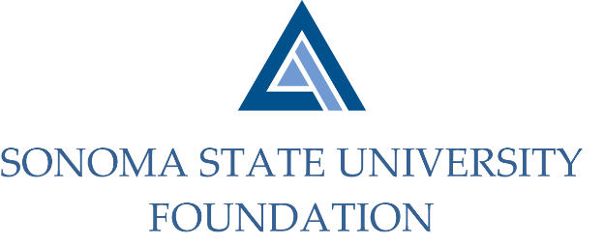

AUDIT COMMITTEE AGENDA

SSU Foundation Audit Committee
September 10, 2021
Video/Teleconference
(for dial-in instructions please email kyle.bishop-gabriel@sonoma.edu)
2 -3pm

Members: Randy Pennington (Chair), Anita Christmas, Jeannette Anglin

Committee Staff: Amanda Visser, Ian Hannah, Stan Nosek, Mario A. Perez, Kyle Bishop-Gabriel, Christina Shoptaugh

OPENING COMMENTS

APPROVAL OF THE MINUTES – 5.10.21

20/21 AUDIT REPORT- Aldrich

EXECUTIVE SESSION

OPEN ITEMS

