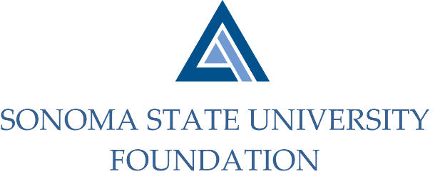

AUDIT COMMITTEE AGENDA

SSU Foundation Audit Committee Agenda
September 10, 2020
Video/Teleconference
(for dial-in instructions please email kyle.bishop-gabriel@sonoma.edu)
2 -3pm

Members: Randy Pennington (Chair), Anita Christmas, Jeannette Anglin

Committee Staff: Amanda Visser, Ian Hannah, Joyce Lopes, Mario A. Perez, Kyle Bishop-Gabriel, Christina Shoptaugh

OPENING COMMENTS

APPROVAL OF THE MINUTES – 5.6.20

19/20 AUDIT REPORT- Aldrich

EXECUTIVE SESSION

AUDIT COMMITTEE CHARTER REVIEW

OPEN ITEMS

