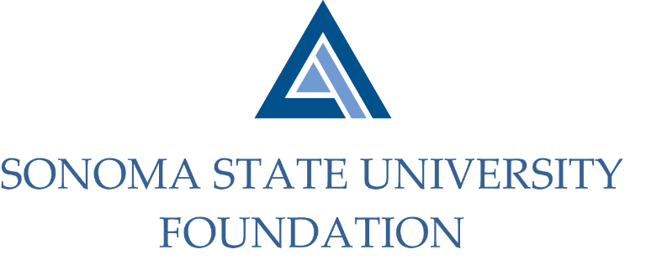

Executive Committee Session of the Board of Directors
September 8, 2021
3:00 – 4:00 pm
Video/Teleconference Meeting
(for dial-in instructions please email kyle.bishop-gabriel@sonoma.edu)

A G E N D A

Call to Order and Approval of Minutes

Review of September 17th SSU Foundation Board Meeting Agenda

Future Special Presentation Topics

New Foundation Logo

Open Items

