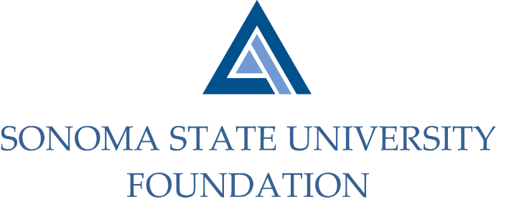

INVESTMENT COMMITTEE AGENDA

SSU Foundation Investment Committee Agenda
Tuesday, August 4th, 2020
Video/Teleconference Meeting
(for dial-in instructions please email kyle.bishop-gabriel@sonoma.edu)
2:30 - 4:30 p.m.

Members: Ian Hannah (Co-Chair), Michael Sullivan (Co-Chair),
Mario Perez, Amanda Visser, Joyce Lopes, Tom Gillespie, Michael Troy, Brent Thomas, Terry Atkinson

Committee Staff: Kyle Bishop-Gabriel, Christina Shoptaugh

Guests: Todd Au, Tony Parmisano, Drew Aviles, Joanna Berg,
and Jeffrey Stein – Graystone Consulting;

Daniel Pantucci and Brian Bonvechio – Merrill Lynch
(3:30pm TIME CERTAIN)

OPENING COMMENTS

APPROVAL OF THE MINUTES
  - 4.29.20 Meeting Minutes

RESULTS FROM NACUBO-TIAA STUDY OF ENDOWMENTS COVID-19 FOLLOW-UP SURVEY

GRAYSTONE – POOLED ENDOWMENT INVESTMENTS
  - Quarterly Update
  - Asset allocation rebalancing to revised targets
  - PowerPoint slides – marketing of SSU endowment

TOWNHOME RENTAL RATE DETERMINATION FOR 2021/22

SALE OF TOWNHOMES

GALBREATH ENDOWMENT INVESTMENTS QUARTERLY/ANNUAL REPORT - 3:30pm TIME CERTAIN

OPEN ITEMS

