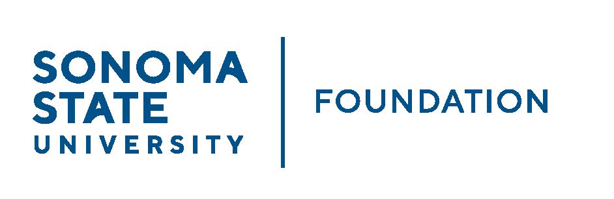

INVESTMENT COMMITTEE MINUTES

SSU Foundation Investment Committee Agenda
Wednesday August 17, 2022
3:00-5:00 p.m.
Video/Teleconference Meeting

Members Present: Brent Thomas (Chair), Ian Hannah, Mario A. Perez,
Amanda Visser, Tom Gillespie, Mike Sullivan,
Doug Jordan

Committee Staff Present: Kyle Bishop-Gabriel

Guests Present: Todd Au, Tony Parmisano, Drew Aviles, Kyle O’Keefe – Graystone Consulting

Members Absent: Monir Ahmed, Terry Atkinson

OPENING COMMENTS

Mario Perez provided a campus update to committee noting the following:

- SSU is at a start of new academic year and this week was the beginning of student’s moving in and back to campus. Many upcoming activities have been planned for new students including a student/parent orientation. The upcoming Friday will be the Fall Convocation at the Green Music Center to kick off the new school year.
- As recently shared, SSU has a new President, Dr. Ming-Tung “Mike” Lee. He has been on campus for 2 weeks and is focused on getting SSU back on its feet and to a place where it was pre-pandemic.
- Advancement has successfully hit fundraising goal for 2nd straight year exceeding the $9.5M goal.

Perez answered follow up questions from committee.

APPROVAL OF THE MINUTES
(see 8.17.22 meeting packet)

Action: Committee unanimously approved 5.4.22 meeting minutes.

GRAYSTONE – POOLED ENDOWMENT INVESTMENTS
(see 8.17.22 meeting packet)

Tony Parmisano from Graystone consulting reviewed the capital market
update with Committee providing high level details in market activities for the
past quarter and up to date and how it’s affected the Foundation’s portfolio.

After capital market update, Parmisano reviewed the Foundation portfolio
performance for the last quarter ending 6.30.22. He noted the portfolio was
down 9.5% QTD and down 10.5% for FY 21/22. He noted that the market
environment has been a lot more challenging with equities taking the biggest
hit, hedge funds holding a little better and private equity and private real
estate performing well. 5-year return = 6.05%.

Todd Au reviewed the trade rationale memo with committee. He noted that
Graystone felt it was a good time to de-risk elements of the portfolio and
Target enhanced diversification with recent market fluctuations. He noted the
changes in equities and fixed income aspects of the portfolio as well as
sharing the list of new managers added.

Au continued to review the Wealth Strategies Analysis report with Committee
To circle back on a question about the distribution power of the portfolio. After
review – Graystone’s recommendation is that the current asset allocation
remains as well as the Foundation’s spending policy.

GALBREATH ENDOWMENT INVESTMENTS QUARTERLY REPORT
(see 8.17.22 meeting packet)

Brent Thomas gave quick summary of the Graystone Quarterly Report
through 6.30.22. He noted the following:

- Portfolio market value as of 6.30.22 = $1.16M
- Current value just over $1.2M following recent rally
- Portfolio is down 14.6% for FY ending 6.30.22.
- 5-year return = 2.5%
- Endowment distribution has been calculated and is anticipated to be made in the Fall.

INVESTMENT POOLS SHEET
(see 8.17.22 meeting packet)

Ian Hannah reviewed the 21/22 Investment Pools Sheet with committee. He
noted the following balances as of 6.30.22:

- Total endowment market value = $60,783,189
  - This figure will be used for SSU’s 2022 NACUBO Endowment Study of Endowments submission.
- SSUF balances match with pools as outlined in the Foundation’s IPS.
- $56.5M (93%) of pool is managed by Graystone.

QUASI ENDOWMENT PROPOSAL
(see 8.17.22 meeting packet)

Hannah reviewed Quasi endow policy that was approved earlier this year by
the Committee. Hannah reminded Committee of the following policy
parameters: “the creation, designation, and dissolution of Quasi-endowment
Funds is at the discretion of the Board of Directors with authority delegated to
the Investment Committee”.

Hannah presented the Palmer Estate quasi endow proposal to the
Committee. Background of the Palmer Estate gift was reviewed. Proposal by
Campus leadership is to commit funds from the estate gift to the following:
70% going to the quasi-endowment and 30% towards current use.

Committee discussed leaderships proposal and had follow up questions
regarding the proposal of % used for current use. Committee discussed and
shared concern to invest more for the longer term and give less for current
use. Perez agreed to discuss further with Provost and President with
committee’s unanimous recommendation to have 80%-90% of funds going
into quasi endowment and 10-20%% for current use.

OPEN ITEMS

Committee had no open items for discussion.

Thomas reminded committee of Board meeting via zoom on Friday 9/23 at
2:30pm

Meeting closed at 4:29pm.
Kyle Bishop-Gabriel – Redacted Signature
Ian Hannah – Redacted Signature

__________________________ ___________________________
Minutes Approved by: Minutes Prepared by:
Ian Hannah Kyle Bishop-Gabriel
Chief Operating Officer & Sr. Advancement/Foundation
Secretary, SSUF Analyst & Asst. to the VP, SSU

