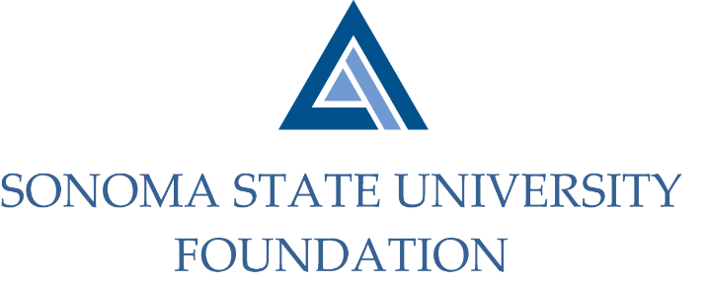

INVESTMENT COMMITTEE AGENDA

SSU Foundation Investment Committee Agenda
Wednesday August 11, 2021
2:00 - 4:00 p.m.
Video/Teleconference Meeting
(for dial-in instructions please email kyle.bishop-gabriel@sonoma.edu)

Members: Ian Hannah (Chair), Mario Perez, Amanda Visser, Stan Nosek, Tom Gillespie, Michael Troy, Brent Thomas, Terry Atkinson

Committee Staff: Kyle Bishop-Gabriel, Christina Shoptaugh

Guests: Doug Jordan
Irv Rothenberg
Todd Au, Tony Parmisano, Drew Aviles, Jeffrey Stein – Graystone Consulting
Daniel Pantucci, Andrea Ratoza – Merrill Lynch

OPENING COMMENTS

APPROVAL OF THE MINUTES
  - 5.6.21 Meeting Minutes

CSU INVESTMENT COMMITTEE UPDATE

INVESTMENT POLICY STATEMENT REVISIONS

GRAYSTONE – POOLED ENDOWMENT INVESTMENTS
  - Quarterly Update
  - Fund/Manager Changes

TOWNHOMES UPDATE

GALBREATH ENDOWMENT INVESTMENTS QUARTERLY/ANNUAL REPORT

INVESTMENT POOLS SHEET

OPEN ITEMS

