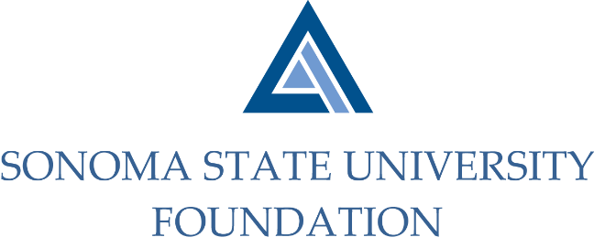

Board of Directors Meeting
Friday June 5, 2020
12:30 – 2:30 pm
Video/Teleconference Meeting
(for dial-in instructions please email kyle.bishop-gabriel@sonoma.edu)

ANNUAL MEETING AGENDA

12:30 pm – Call to Order

Approval/Confirmation of Board of Directors and Committee membership appointments for FY 2020/2021
- Membership List
- Vote - New Board & Committee Members
- Annual Review of Board Members Statement of Understanding

Adjournment to Regular Meeting

QUARTERLY BOARD MEETING AGENDA

Call to Order

Public Comment Period
- Pursuant to California Education Code 89920-28, this time is for any member of the public to address the Board on any item affecting higher education. Each speaker will be allowed no more than three (3) minutes to address the Board, total max of 10 mins.

Consent Agenda
- March 13, 2020 Board Minutes
- Quarterly Financial Statement
- Graystone Quarterly Performance Report

University President’s Report
- University Update

Special Presentation

Committee Reports
- Audit Committee Report
- Governance Committee Report
- Investment Committee Report
- Executive Committee Report

Action Items
- Revised Foundation Strategic Plan 2025
- Revised Bylaws
- 2020/21 SSUF Operating Budget
- Fall 2020 pooled endowment distribution
- Foundation Townhomes Proposal

University Advancement Report
- Quarterly Philanthropic Summary Report

Student Update

Alumni Association Update

New Business / Announcements / Adjournment

Next Meeting Date:
September 18, 2020 12:30 – 2:30 pm

