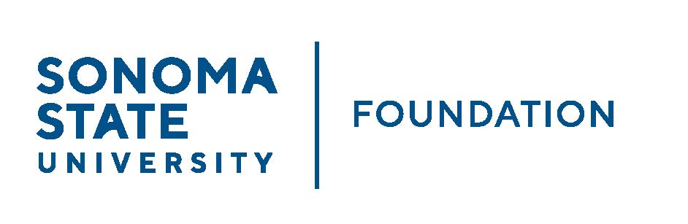

AUDIT COMMITTEE MINUTES

May 6, 2022
3:30-4:30pm
Video/Teleconference

Members Present: Randy Pennington (Chair), Jeannette Anglin,
Mike Sullivan

Committee Staff Present: Amanda Visser, Ian Hannah, Monir Ahmed,
Mario Perez, Kyle Bishop-Gabriel,
River Christina Cullen

Guests Present: Andy Maffia, Jon Hu - Aldrich

Members Absent: Anita Christmas

OPENING COMMENTS

Randy Pennington opened meeting at 3:32pm.

Pennington welcome Mike Sullivan as a new committee member as well as Monir Ahmed as a new staff member to the Committee.

Pennington announced Andy Maffia will be SSUF’s new partner this year under Aldrich and will be overseeing this year’s audit.

APPROVAL OF THE MINUTES – 9.10.21
(see 5.6.22 meeting packet)

Action: Committee unanimously approves minutes from 9.10.21.

AUDIT PLAN & TIMELINE FOR 21/22 FISCAL YEAR – Aldrich
(see 5.6.22 meeting packet)

Andy Maffia introduced himself along with Senior Manager Jonathan Hu.

Maffia reviewed Audit timeline with Committee, which covered the following:

- Scope of services
- Client service team
- Service timeline (planning and interim work begins 6/20/22 with field work in beginning of August)
- Focus of significant audit areas and issues and fraud considerations.

Maffia also noted that Aldrich completed routine peer review in April 2020 and received a passing grade. They currently work with 8 of 23 CSU campuses and 23 or 24 of the 90 CSU auxiliaries.

COMPLIANCE REVIEW REPORT
(see 5.6.2 meeting packet)

Amanda Visser reported to Committee and reviewed this year’s scholarship compliance review report. She shared that a collective group of members from finance and scholarship offices meet every year to review a sampling of scholarship awarding to ensure that awarding is in line with donor intent.

She shared that based on an Audit Committee suggestion from last year, the compliance review group changed the sampling to incorporate ensuring review of at least one larger endowment fund over $300k.

Visser noted that the report was emailed to Committee members Anita Christmas and Pennington on 1/28/22 for review.

There were only a few bullet points of note in the review, but overall the review proved to be successful.

AUDIT COMMITTEE CHARTER REVIEW
(see 5.6.22 meeting packet)

Pennington brought attention to the annual review of Audit Committee Charter and noted that the review is to make sure nothing of note needed to be updated or changed.

Pennington recommend to give the final review at next meeting.

OPEN ITEMS

Meeting adjourned at 4:16pm.

Kyle Bishop-Gabriel – Redacted Signature
Ian Hannah – Redacted Signature

___________________________ ______________________
Minutes approved by: Minutes prepared by:
Ian Hannah Kyle Bishop-Gabriel
Chief Operating Officer and Secretary, Sr. Advancement/Foundation
SSU Foundation Analyst & Asst. to the VP, SSU

