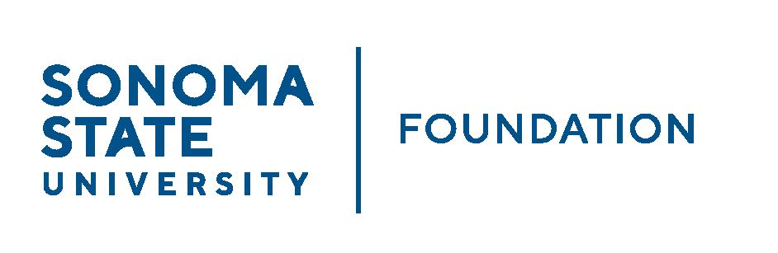

AUDIT COMMITTEE AGENDA

SSU Foundation Audit Committee Meeting
May 6, 2022
3:30-4:30pm
Video/Teleconference
(for dial-in instructions please email bishopk@sonoma.edu)

Members: Randy Pennington (Chair), Anita Christmas, Jeannette Anglin, Mike Sullivan

Committee Staff: Amanda Visser, Ian Hannah, Monir Ahmed,
Mario Perez, Kyle Bishop-Gabriel, River Christina Cullen

OPENING COMMENTS

APPROVAL OF THE MINUTES – 9.10.21

AUDIT PLAN & TIMELINE FOR 21/22 FISCAL YEAR – Aldrich

COMPLIANCE REVIEW REPORT

AUDIT COMMITTEE CHARTER REVIEW

OPEN ITEMS

