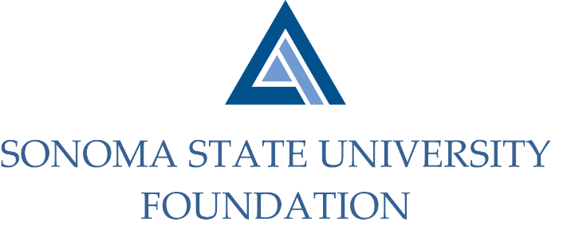

INVESTMENT COMMITTEE AGENDA

SSU Foundation Investment Committee Agenda
Wednesday May 6, 2021
Video/Teleconference Meeting
(for dial-in instructions please email kyle.bishop-gabriel@sonoma.edu)
2:30 - 4:30 p.m.

Members: Ian Hannah (Co-Chair), Michael Sullivan (Co-Chair),
Mario Perez, Amanda Visser, Joyce Lopes, Tom Gillespie, Michael Troy, Brent Thomas, Terry Atkinson

Committee Staff: Kyle Bishop-Gabriel, Christina Shoptaugh

Guests: Todd Au, Tony Parmisano, Drew Aviles, Joanna Berg,
Jeffrey Stein – Graystone Consulting

OPENING COMMENTS

APPROVAL OF THE MINUTES
  - 3.9.21 Meeting Minutes

SUSTAINABILITY TRACKING, ASSESSMENT & RATING SYSTEM (STARS) - INVESTMENT DISCLOSURE SECTION – stars.aashe.org

GRAYSTONE – POOLED ENDOWMENT INVESTMENTS
  - Quarterly Update
  - NACUBO Endowment Study Comparison

GALBREATH ENDOWMENT INVESTMENTS QUARTERLY REPORT

FALL 2021 POOLED ENDOWMENT DISTRIBUTION

2021/22 SSUF OPERATING BUDGET

FOUNDATION OPERATING RESERVE POLICY

OPEN ITEMS

