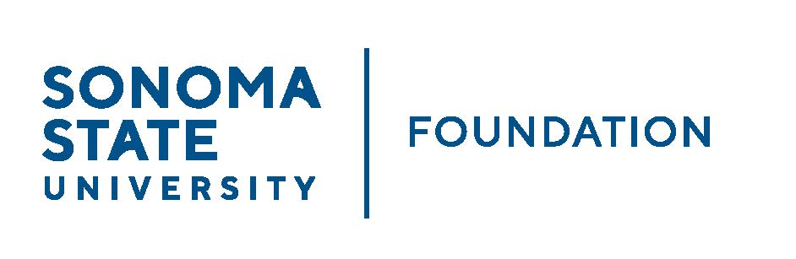

INVESTMENT COMMITTEE MINUTES

Wednesday May 4, 2022
2:30 - 4:30 p.m.
Video/Teleconference Meeting

Members Present: Brent Thomas (Chair), Ian Hannah, Mario A. Perez,
Amanda Visser, Monir Ahmed, Tom Gillespie, Mike Sullivan, Doug Jordan

Committee Staff: Kyle Bishop-Gabriel, River Christina Cullen

Guests: Todd Au, Tony Parmisano, Drew Aviles, Kyle O’Keefe – Graystone Consulting;
Nick Mendelson; Michael Santos

Members Absent: Terry Atkinson

OPENING COMMENTS

Meeting opened at 2:31pm.

Ian Hannah welcomed back Board member Mike Sullivan after a year leave of absence. Sullivan returns as an Investment and Audit committee member. Hannah also noted an additional new Committee member Monir Ahmed, Vice President of Administration and Finance, who joined the Board recently as a designated director by position on campus.

Mario Perez then provided a campus update to Committee and noted the following:

- SSU has been in the headlines lately which has created a bit of a challenging environment but staff continue to push forward and proceed with important work for the campus.
- Advancement and fundraising efforts continue to move forward and are on track to reach SSU’s annual fundraising goal for this year. The division had a very successful Giving Day, bringing in $267K of donations from over 400 donors.
- Advancement recently lost 1 Director of Development (DOD) as well as the Senior Director for Development for the Green Music Center. Both individuals moved on to different positions outside of SSU. Recruitment for these vacant positions and an additional DOD/vacant frontline fundraiser position have been posted.

Perez answered questions from Committee regarding current issues on campus.

APPROVAL OF THE MINUTES
(see 5.4.22 meeting packet)

Action: Committee unanimously approved minutes from 2.9.22.

GRAYSTONE – POOLED ENDOWMENT INVESTMENTS
(see 5.4.22 meeting packet)

Tony Parmisano provided the capital market update to committee and noted the following:

- Ukraine war has caused volatility in the market for this past quarter.
- Commodities have been the strongest performers coming out of the pandemic with energy leading the way.
- Expecting recovery to continue to be short and quick compared to other recoveries over the past 30 years.
- Inflation is elevated and Fed is in position now to where they have to raise interest rates and at a greater magnitude than expected. Expecting that fed rates will likely flatline in 2023.

Parmisano continued into a high-level review of endowment portfolio. He noted the portfolio was down 5.41% quarter to date (QTD) ending 3.31.22 and down 1.51% fiscal year to date (FTD).

Todd Au moved into reviewing recent changes made to the portfolio with Committee. He explained to committee that some trades were made in the portfolio to take advantage of cyclical exposure. And with issues happening globally and nationally, Graystone decided to somewhat de-risk the portfolio.

Au concluded with a review of trade rational along with portfolio changes and the changes within each asset class.

Lastly, Au reviewed the 20/21 NACUBO Endowment Report comparing SSU Foundation’s peer group.

Au and Parmisano answered questions from committee.

GALBREATH ENDOWMENT INVESTMENTS QUARTERLY REPORT
(see 5.4.22 meeting packet)

Brent Thomas gave quick quarterly report on the Galbreath endowment. He noted the following:

- Portfolio is down 6.7% for QTR ending 3/31/22.
- 5-year annual return = 5.5%

FALL 22/23 POOLED ENDOWMENT DISTRIBUTION
(see 5.4.22 meeting packet)

Hannah reviewed the proposed Fall 2022 endowment distribution totaling approximately $1.8M. The distribution will be the largest in SSU history and shows a gradual increase over the last decade of annual distributions. The distribution will support scholarships and programmatic needs on campus.

The larger distribution reflects a result of new donations and cumulative investment returns, along with a spending policy designed to smooth distribution amounts year over year.

Hannah highlighted the notable additions which included a $2.5M from Green family estate as well as proceeds from sale of townhomes supporting endowment funds with purposes of faculty development and also performing arts.

Action: Committee approves of the Fall 2022 distribution and moves to recommend approval from the Board.

2022/23 SSUF OPERATING BUDGET
(see 5.4.22 meeting packet)

Amanda Visser reviewed with committee the 2022/23 proposed SSUF Operating Budget. She noted the following items:

- Revenues based primarily on 1% annual endowment management fee.
- Expenses largely from: cost recovery to University, audit fees, and transfer to Advancement to support fundraising and philanthropic efforts.

Action: Committee approves of 2022/23 proposed operating budget and moves to recommend approval from the Board.

STUDENT MANAGED INVESTMENT FUND (SMIF)
(see 5.4.22 meeting packet)

Michael Santos, faculty advisor to SMIF, began reviewing some of the elements of the program with Committee. He noted that most of the interaction with the students and work for the program is done by Nick Mendelson, alum and volunteer investment advisor for SMIF.

Nick Mendelson joined meeting and proceed to review the SMIF report with committee emphasizing that the main goal of the program is to bring an internship experience to campus to make it accessible to students who wouldn’t have the opportunity otherwise.

Mendelson shared his main priority is to help students with job placement and he noted there has been successful job placement for several students who took part in the program.

Mendelson shared he hopes students have the option to receive class credit for their participation sometime in the future

In appreciation of Mendelson’s efforts, Hannah presented a certificate of appreciation from the Foundation for volunteering his time and making an impact with SSU students.

OPEN ITEMS

Hannah noted that the quasi endowment proposal is still being worked on and will be prepared and reviewed for the next or future committee meeting.

Committee was reminded of next Board meeting which will be held June 17^{th.}

Meeting closed at 4:34pm.

__________________________ ________________________
Minutes Approved by: Minutes Prepared by:
Ian Hannah Kyle Bishop-Gabriel
Chief Operating Officer & Sr. Advancement/Foundation
Secretary, SSUF Analyst & Asst. to the VP, SSU

