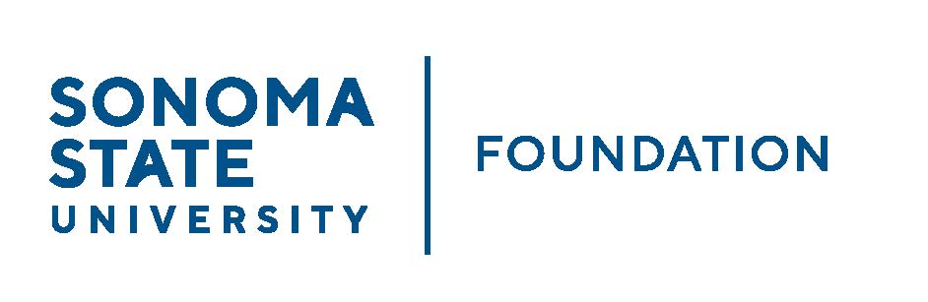

INVESTMENT COMMITTEE AGENDA

SSU Foundation Investment Committee Agenda
Wednesday May 4, 2022
2:30 - 4:30 p.m.
Video/Teleconference Meeting
(for dial-in instructions please email bishopk@sonoma.edu)

Members: Brent Thomas (Chair), Ian Hannah, Mario A. Perez, Amanda Visser, Monir Ahmed, Tom Gillespie, Terry Atkinson, Mike Sullivan, Doug Jordan

Committee Staff: Kyle Bishop-Gabriel, River Christina Cullen

Guests: Todd Au, Tony Parmisano, Drew Aviles – Graystone Consulting;
Nick Mendelson, Michael Santos

OPENING COMMENTS

APPROVAL OF THE MINUTES
  - 2.9.22 Meeting Minutes

GRAYSTONE – POOLED ENDOWMENT INVESTMENTS
  - Quarterly Update
  - NACUBO Endowment Study Results
  - New Fund Manager

GALBREATH ENDOWMENT INVESTMENTS QUARTERLY REPORT

FALL 22/23 POOLED ENDOWMENT DISTRIBUTION

2022/23 SSUF OPERATING BUDGET

STUDENT MANDAGED INVESTMENT FUND (SMIF) REPORT

OPEN ITEMS

