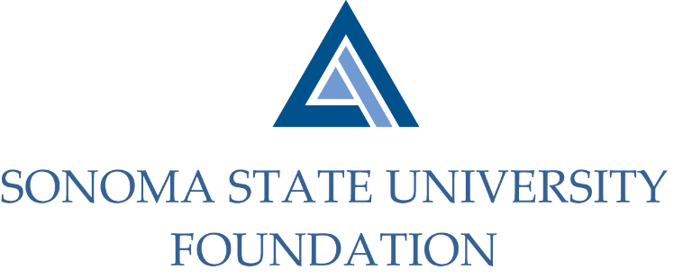

SSU Foundation Governance Committee
Thursday May 21, 2020
3:00 – 4:30 p.m.
Zoom/Teleconference

GOVERNANCE COMMITTEE MINUTES

Members Present: David Felte (Chair), Ian Hannah, Terry Atkinson, Tom Isaak

Committee Staff Present: Kyle Bishop-Gabriel

Members Absent: Mario A. Perez, Randy Pennington, Sam Brown

Opening Comments

Hannah opened meeting at 3:00pm.

He noted member absences and there were enough members present to meet quorum.

Before proceeding with meeting Hannah provided committee members with an update of the current campus happenings and decisions being faced during COVID-19 pandemic. Hannah noted that the CSU and SSU’s campus leadership are working through a dynamic situation.

The following was shared with committee:
- Commencement was held as a virtual celebration/recognition on Sat 5/16. Students were surveyed to select a date for inperson commencement at a later time.
- Chancellor Timothy White, in reporting to the Board of Trustees about COVID-19 implications for the CSU on May 12th, stated that the planning framework for course delivery across the system will be primarily virtual for Fall 2020.
- President Sakaki appointed an Academic Continuity Planning Group and an Operational Continuity Planning Group to help address the many questions we all have about campus operations in the fall. These include questions about what classes may be allowed to meet in person, how students will be housed and whether/when staff and faculty will be allowed to physically return to campus.
- Currently, campus leadership has extended the temporary telecommuting program. The soonest some employees may return to office is currently July 6th and will likely happen in a phased-in approach.

Hannah shared with committee that upon Perez reviewing the Governance Committee Charter and Purpose his expectations looking forward include creating a Board everyone wants to be a part of and to look for those who would be invested in working on initiatives together.

Approval of the Minutes
(see 5.21.20 meeting packet)

Action: Committee unanimously approved 10.24.19 Governance Committee minutes.

Board of Directors Statement of Understanding Review
(see 5.21.20 meeting packet)

Hannah did a quick review of the current Board of Directors Statement of Understanding which typically is presented to the Board as an annual reminder and symbolizes a renewal of Board members’ committement to the SSU Foundation.

Hannah noted that Perez will intend to do a more in depth review of the statement and potentially may make changes. Hannah also encouraged committee to provide feedback if they have any suggested edits.

Bylaws Revisions
(see 5.21.20 meeting packet)

Hannah reviewed with committee changes being made to the Foundation’s by-laws up for review
and approval. He noted the following changes:
- Acting Board Chair title replaced with Vice Chair for better clarity on role.
- Philanthropy Committee added as committee to the Board.
- Addition of Alumni Association Board rep to improve cross communications between SSU Foundation and Alumni Association.
- Update committee terms/length of service to coincide with Board terms.
- Still finalizing decision of University Provost being a Designated Director on the Board, a possible future change for that role.

Action: Committee approves of changes and recommends to Executive Committee for review.

Current Board Matrix and Participation
(see 5.21.20 meeting packet)

Hannah reviewed updated Board matrix document. He noted the following:

- Philanthropy Committee and members were added.
- Thirteen Board directors are up for term renewal and an attempt was made by Felte and Perez to contact each director and discuss their desire to continue serving.
  - Current Faculty rep Dr. John Kornfeld willing to stay on a little longer until new Faculty rep is identified.
  - Two members have identified desire to step down, Mr. Sam Brown and Mr. Herm Benedetti.
  - Most of the other members expressed desire to continue, with a couple that have been harder to reach but will be contacted prior to Board meeting.
- With some of the Board membership changes, some committees will be affected by those stepping down. Both Governance and Audit Committee will be losing members and will be looking to recruit others to fill those spots.
- Members stepping down and/or leaving due to Board terms ending will receive parting gifts once able to give them.

Potential New Board and Committee Members
(see 5.21.20 meeting packet)

List of potential new Board members and Board Committee members was reviewed. New Board
member Ms. Melissa Kadar, President of SSU Associated Students will be presented to Board for
approval at next meeting. A new Faculty rep to fill Dr. Kornfeld’s spot on the Board will likely be
presented at the September Board meeting, as well as the Alumni Association Board rep. At this
time no new community members have been identified as ready to begin membership on the Board.
Hannah asked Committee members if they had recommendations they would like to share or think
would be a good addition to the Board to let himself or Perez know.

Open Items

Before adjourning meeting, Hannah shared with Committee and “exit” interview with Dr. Kornfeld and received good feedback which he shared with the Committee.

Meeting adjourned at 4pm.

Signature of Kyle Bishop-Gabriel - Redacted
Signature of Ian Hannah - Redacted

__________________________ ___________________________
Minutes Approved by: Minutes Prepared by:
Ian Hannah Kyle Bishop-Gabriel
Chief Operating Officer & Advancement/Foundation Analyst, SSU
Secretary, SSUF

