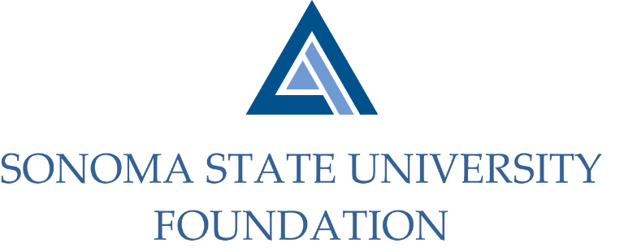

COMBINED PHILANTHROPY & GOVERNANCE COMMITTEE AGENDA

SSU Foundation Philanthropy & Governance Committees
Thursday May 20, 2021
Zoom/Teleconference
(for dial-in instructions please email kyle.bishop-gabriel@sonoma.edu)
2:00 – 3:30 p.m.

Members: Terry Atkinson (Chair - Phil), David Felte (Chair – Gov), Tom Isaak (Phil & Gov), Robert U’Ren (Phil), Jeannette Anglin (Gov), Ian Hannah (Phil & Gov), Mario Perez (Phil & Gov)

Committee Staff: Kyle Bishop-Gabriel

Opening Comments

Approve Meeting Minutes
  - 11.12.20 Governance Committee
  - 2.18.21 Philanthropy Committee

Update on Philanthropic Productivity through Q3 of FY20/21

SSUF Board Member Giving Minimums
  - CSU Comparative Spreadsheets
  - Draft Revised Statement of Understanding

Nominations and Potential New Board and Committee Members

Open Items

