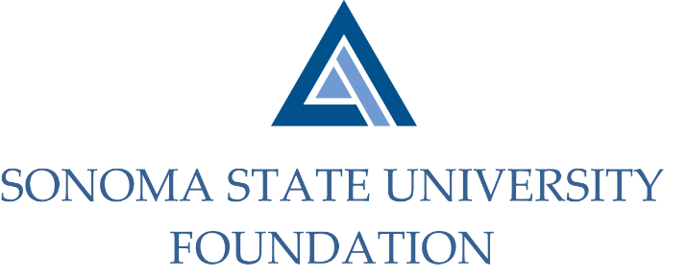

INVESTMENT COMMITTEE MINUTES

Tuesday March 9, 2021
Video/Teleconference Meeting
2:30 - 4:30 p.m.

Members Present: Ian Hannah (Co-Chair), Michael Sullivan (Co-Chair),
Amanda Visser, Tom Gillespie, Michael Troy, Brent Thomas, Terry Atkinson

Committee Staff Present: Kyle Bishop-Gabriel, Christina Shoptaugh

Guests Present: Todd Au, Tony Parmisano, Drew Aviles – Graystone Consulting

Members Absent: Mario A. Perez, Joyce Lopes

OPENING COMMENTS

Meeting opened at 2:33pm.

Ian Hannah offered a quick campus update to Committee in regards to SSU’s recent Commencement decisions as well as campus repopulation plans for the Fall 2021 semester.

Hannah noted there was a recent inquiry from SSU’s Associated Students (AS) regarding any Foundation investments in fossil fuels. Hannah shared the relevant section of Graystone’s report breaking out the level of investments in such areas and noted that positive screening for ESG factors has resulted in a reduced exposure to investment funds carrying fossil fuel related companies. Hannah has not had any follow up inquiries since sharing the report but noted that the conversation continues to pop up around the topic of various sustainable investing tactics. Hannah also informed Committee there is an increased awareness of diversity and inclusion in investment managers, as it was a topic well covered in the recent 19/20 NACUBO-TIAA Study of Endowments.

APPROVAL OF THE MINUTES
(see 3.9.21 meeting packet)

Action: Committee unanimously approved 10.29.20 meeting minutes.

NACUBO-TIAA STUDY OF ENDOWMENTS 19/20 COMPARATIVE DATA
(see 3.9.21 meeting packet)

Hannah reviewed comparative data sheet with Committee and shared brief highlights.

- Total SSUF Endowment Market Value as of 6.30.20 = $52.7M.
- SSUF Return Objective of 6.5%-7.5% similar to NTSE Average Long Term Objective of 7%.
- SSUF asset allocations mostly aligned with NTSE $51-100M peer group allocations.
- SSUF investment return outperformed peers during FY 19/20 due to growth oriented changes made to asset class targets but performance averages during longer time horizons underperformed due to historically more conservative asset allocation.
- SSUF’s ESG focused Sustainable Investing Position Statement is consistent with majority of peers.

Hannah concluded with other minor notes of comparison.

GRAYSTONE – POOLED ENDOWMENT INVESTMENTS
(see 3.9.21 meeting packet)

Tony Parmisano gave the most recent quarterly market report to committee. He noted equities, primarily domestic equities performed the best along with fixed income and hedge funds. Real assets have continued to struggle the most.

Parmisano proceeded to report on the Endowment’s 12.31.20 quarterly performance which ended at 9.8% with fiscal year to date performance at 15.9%.

Parmisano also reviewed upcoming portfolio changes Graystone will be making which will be followed up with a memo to the Committee.

Todd Au directed Committee to a quick preview of the Endowment Board presentation that will be given at the next Board meeting on March 19th.

GALBREATH ENDOWMENT INVESTMENTS QUARTERLY REPORT
(see 3.9.21 meeting packet)

Hannah provided a brief review of the Galbreath Endowment quarterly report as of 12.31.20 which included investment returns just over 7.4%.

FOUNDATION OPERATING RESERVE POLICY
(see 3.9.21 meeting packet)

Hannah did a quick review of the current Foundation Operating Reserve Policy that was last updated in 2002. He noted staff will be looking to revise the policy to be updated with current standards, most notably indicating a goal and minimum of reserve funds. Staff intend to have it ready for review at the next Committee meeting.

Hannah encouraged Committee to share any thoughts or input before the next meeting.

OPEN ITEMS

Before adjourning meeting, Hannah shared with Committee that the Foundation townhome sales are going well. So far 5 of the 10 have been sold. Net proceeds of the first 4 will be deposited into the overall Endowment while the remaining funds will go into designated funds for two different endowed campus programs, in line with donor intent.

Meeting adjourned 3:41pm.

Kyle Bishop-Gabriel – Redacted Signature
Ian Hannah – Redacted Signature
__________________________ ___________________________
Minutes Approved by: Minutes Prepared by:
Ian Hannah Kyle Bishop-Gabriel
Chief Operating Officer & Sr. Advancement/Foundation
Secretary, SSUF Analyst, SSU

