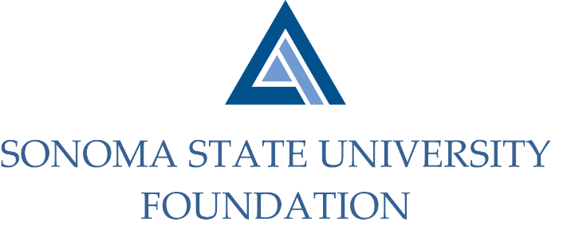

INVESTMENT COMMITTEE AGENDA

SSU Foundation Investment Committee Agenda
Tuesday March 9, 2021
Video/Teleconference Meeting
(for dial-in instructions please email kyle.bishop-gabriel@sonoma.edu)
2:30 - 4:30 p.m.

Members: Ian Hannah (Co-Chair), Michael Sullivan (Co-Chair),
Mario A. Perez, Amanda Visser, Joyce Lopes, Tom Gillespie, Michael Troy, Brent Thomas, Terry Atkinson

Committee Staff: Kyle Bishop-Gabriel, Christina Shoptaugh

Guests: Todd Au, Tony Parmisano, Drew Aviles – Graystone Consulting

OPENING COMMENTS

APPROVAL OF THE MINUTES
  - 10.29.20 Meeting Minutes

NACUBO-TIAA STUDY OF ENDOWMENTS 19/20 COMPARATIVE DATA

GRAYSTONE – POOLED ENDOWMENT INVESTMENTS
  - Quarterly Update
  - Preview of March Board endowment presentation

GALBREATH ENDOWMENT INVESTMENTS QUARTERLY REPORT

FOUNDATION OPERATING RESERVE POLICY

OPEN ITEMS

