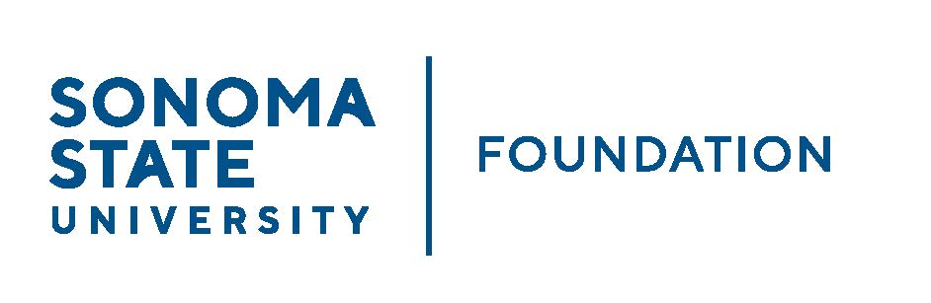

AUDIT COMMITTEE AGENDA

SSU Foundation Audit Committee Meeting
May 9, 2024
3:30-4:30pm
Location: Salazar 2043B or via Zoom
(For dial-in instructions please email foundation@sonoma.edu)

Members: Randy Pennington (Chair), Anita Christmas,
Mike Sullivan, Brigitte Lahme, Josh Goff

Committee Staff: Amanda Visser, Ian Hannah, Monir Ahmed,
Mario Perez, Alicia Hodenfield, Kristin Hillman

- OPENING COMMENTS

- APPROVAL OF THE MINUTES – 9.12.2023

- AUDIT PLAN & TIMELINE FOR 23/24 FISCAL YEAR – ALDRICH

- SCHOLARSHIP COMPLIANCE REVIEW REPORT

- AUDIT COMMITTEE CHARTER REVIEW

- OPEN ITEMS

