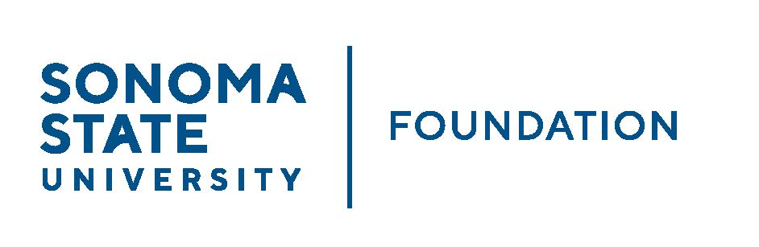

INVESTMENT COMMITTEE AGENDA

SSU Foundation Investment Committee
Wednesday May 1, 2024
3:00 - 5:00 p.m.
Location: Salazar 2043B or Zoom
(for dial-in instructions please email hodenfie@sonoma.edu)

Members: Brent Thomas (Chair), Ian Hannah, Mario A. Perez,
Amanda Visser, Monir Ahmed, Tom Gillespie, Mike Sullivan,
Doug Jordan, Ali Pourghadir

Committee Staff: Alicia Hodenfield, Kristin Hillman

Guests: Todd Au, Tony Parmisano, Drew Aviles – Graystone Consulting
Jim Scheinberg or delegate – North Pier Consulting

- OPENING COMMENTS

- CONSENT AGENDA
  - Approval of the Minutes - 2.27.24 Meeting Minutes
  - Galbreath Endowment Investments Quarterly Report

- GRAYSTONE – POOLED ENDOWMENT INVESTMENTS
  - Quarterly Update: capital markets update and portfolio review
  - Action: New private equity fund: Coller International Partners IX
  - NCSE results comparison

- 2024/25 POOLED ENDOWMENT DISTRIBUTION

- 2024/25 SSUF OPERATING BUDGET

- OPEN ITEMS

