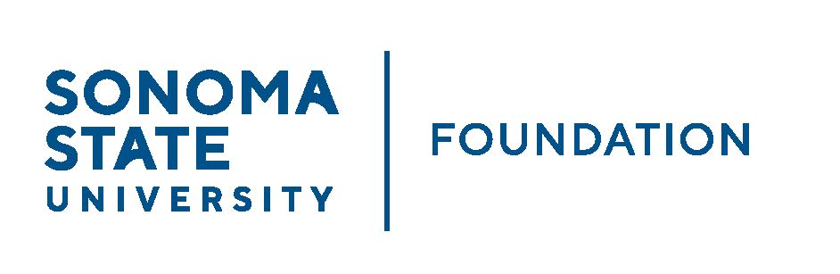

INVESTMENT COMMITTEE AGENDA

SSU Foundation Investment Committee
Tuesday August 22, 2023
2:30 - 4:30 p.m.
HYBRID meeting: Salazar 2043B or Zoom

Members Present: Brent Thomas (Chair) (z), Ian Hannah (z), Mario A. Perez,
Amanda Visser, Monir Ahmed, Tom Gillespie (z),
Mike Sullivan (z), Doug Jordan

Members Absent: Terry Atkinson

Committee Staff Present: Alicia Hodenfield

Guests: Todd Au, Tony Parmisano, Drew Aviles (z) – Graystone Consulting

Absent: Terry Atkinson

- OPENING COMMENTS
Brent Thomas opened the meeting at 2:29pm. Brent introduced Alicia Hodenfield as the new staff support to Foundation Board and Committees.

Mario Perez provided a brief campus update to the Committee. He noted the following:
- Exciting week, feels like we are back to normal. There’s a vibrant energy on campus with our students return. Move in started a week ago with our student athletes and last week everyone else. Advancement with our campus partners including Student Affairs, hosted the parents with a wine reception, about 250 attended. President Lee welcomed everyone and provided a few remarks. The rest of the evening was spent engaging with the parents. The feedback we’ve received has been wonderful.
- We are on the last year of the enrollment downswing, as the last commencement in May 2023 was the last of larger graduating classes. Our faculty has done an amazing job at keeping our students on track and graduating. Our current enrollment is less than 6,000 in headcount. Ed Mills just started a VP for Strategic Enrollment Management and SSU is excited at what he has planned.
- Fundraising at other CSU campuses appears generally down in FY 22/23, however at SSU we were able to surpass our goal of $10 million and hit $11 million in gift commitments.
- Today University Advancement had a gathering of our campus partners to thank them for their collaboration and everything they do to support our work. The work we are doing now will help in preparation for a future comprehensive campaign.

- APPROVAL OF THE MINUTES
(see 8.22.23 meeting packet)

Action: Committee unanimously approved the 5/16/23 meeting minutes.

- GRAYSTONE – POOLED ENDOWMENT INVESTMENTS
(see 8.22.23 meeting packet)

Todd Au provided the commentary and Quarterly Update on the Capital Markets to the Committee. SSUF’s pooled endowment investment returns for the latest quarter as of 6/30/23 = 2.8% and FY 22/23 performance = 7%. Hannah noted the 7% return figure will be used for the upcoming NACUBO TIAA Endowment Survey (NTSE) submission.

Au reviewed overall market performance for equities, fixed income, hedge funds and real assets. He noted that the returns through 6/30/23 are very strong.

Tony Parmisano provided a portfolio breakdown and market assessment. The market will likely be seeing more volatility as markets are overvalued today. A conservative position is being held in the portfolio relative to strategic targets.

The Private equity funds have been performing well. Though there is illiquidity with these, the expected return is higher. Will recommend at the next meeting an allocation to a new Private Equity fund.

- GALBREATH ENDOWMENT INVESTMENTS QUARTERLY REPORT
(see 8.22.23 meeting packet)

Ian Hannah provided the Quarterly Update thru 6/30/23. The market value as of 6/30/23 market value is $1.2M. The performance as of this quarter is 3.4%; looking back one year = 8.4%; and 5 years = 3.1%. As this compares to Graystone’s results (albeit different strategic asset allocation): this quarter = 2.8%; one year = 7%; 5 years = 6.1%.

The investment manager noted: “Performance last year was pretty much in-line with other diversified portfolios with the same allocation and no alternative investments. With the historic drawdown in the fixed income markets due to the Fed’s tightening, we have above average expectation for the fixed income going forward.”

The endowment distribution to be calculated and made in the Fall based on Galbreath endow spending policy of 3% of three year rolling avg (= roughly $38K).

- INVESTMENT POOLS SHEET
(see 8.22.23 meeting packet)
Ian Hannah reviewed the Investment Pools.

Balances as of 6/30/23
- SSUF balances are in line with pools (Cash; Endowment; Special Investments) as outlined in the Foundation’s Investment Policy.
- Total endowment market value = $65,197,471 (a record FYE balance for SSUF). This total will be used for SSU’s 2023 NACUBO Endowment Study submission. $59.6M (91%) of this is pooled and managed by Graystone.

- 2023/24 SSUF OPERATING BUDGET
(see 8.22.23 meeting packet)

Ian Hannah reviewed the proposed revised 23/24 SSUF operating budget. There had been questions from the board regarding the $10K initially budgeted then tabled expense related to CSU campaign contribution for General Obligation Bonds. Counsel sought from SSUF Counsel, Jeremy Olsan. Olsan responded that this would be an authorized use of funds and would not put SSUF or its board members in violation of the codes and policies that guide the auxiliary.

Action: Committee agreed to move revised budget forward to Board for approval.

Ian also reviewed the financials and operating budget actuals as of 6/30/23.

- SMIF CHARTER

Ian Hannah provided a brief update to the SMIF account. As of 6/30/23 SMIF balance with TD Ameritrade = $12,251.

TD Ameritrade merging with Charles Schwab and log-in/platform soon to change to Schwab.

Faculty advisor for SMIF in transition last year from Dr. Santos to Dr. Hu. Now transitioning back to Dr. Santos.

Upon periodic review of SMIF charter and taking in to consideration the above factors, an updated draft charter is being presented for committee to review before putting in from of the full Board for approval. Ian worked with Dr. Mike Visser, Interim Dean of the School of Business and Economics on the edits.

Primary changes include changing log-in access for trade execution to be conducted by an administrator in SBE, previously performed by faculty advisor.

Also, lists current SMIF Advisory Board members as an addendum so the charter does not have to be updated every time there is a change to identified individuals.

Disclosures related to committee members (not considered conflicts but could be perceived as a conflict and thus disclosing for transparency): Doug is former faculty advisor for SMIF, Amanda is married to current interim Dean of SBE, Brent/Brent’s firm is a donor to SMIF.

The committee additionally recommended removing the statement “The majority of members of the Advisory Board should not also be donors to the fund.” In section 1. Background.

Action: The committee unanimously approved various revisions to the SMIF Charter to be submitted to the Board for approval at the next meeting.

- OPEN ITEMS

Brent Thomas announced the next Board meeting is Friday, September 22, 10am-noon at Sonoma Valley Room followed by lunch from noon-1pm. There will also be a zoom option for those unable to attend in person.

The meeting was adjourned at about 3:45pm.

Alicia Hodenfield – Redacted Signature
Ian Hannah – Redacted Signature

Minutes approved by: Minutes prepared by:
Ian Hannah Alicia Hodenfield
Chief Operating Officer & Administrative Manager for
Secretary, SSUF Advancement and Foundation
Operations

