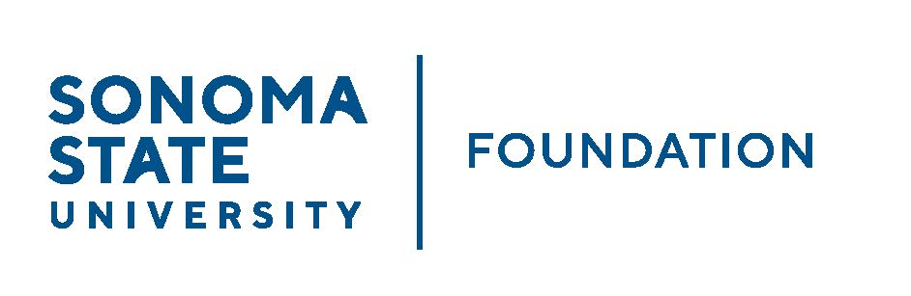

INVESTMENT COMMITTEE MINUTES

Wednesday February 9, 2022
2:30 - 4:30 p.m.
Video/Teleconference Meeting

Members Present: Brent Thomas (Chair), Ian Hannah,
Mario A. Perez, Amanda Visser, Terry Atkinson,
Doug Jordan

Committee Staff Present: Kyle Bishop-Gabriel, Christina Shoptaugh

Guests Present: Todd Au, Tony Parmisano, Kyle O’Keefe – Graystone Consulting

Members Absent: Tom Gillespie, Monir Ahmed

OPENING COMMENTS

Brent Thomas opened meeting at 2:30pm.

Ian Hannah provided an update on Mike Sullivan, Board and Committee member, who had gone out on a leave of absence last year. He announced Sullivan reached out about returning to an active status on the Board and with the Committee. He also agreed to become a member of the Audit Committee to give cross representation of each Committee.

Hannah proceed with announcing the new SSU CFO and Vice President for Administration and Finance, Monir Ahmed. Hannah shared Ahmed’s bio and noted he was unable to attend the day’s meeting but will be a designated director of Board by nature of his campus position and will also join the Investment Committee.

Mario Perez provided a brief campus update with the Committee. He noted that due to the recent COVID surge, campus had to scale back the repopulation plan but after February 11th will begin moving into the next phase of repopulation with a broader return to campus.
Perez answered follow-up questions from committee regarding repopulation and about returning to in-person meetings.

Lastly Perez shared recent update on Advancement’s philanthropic efforts in the past quarter and noted that the campus had a great end to the 2nd quarter.

APPROVAL OF THE MINUTES

(see 2.9.22 meeting packet)

Thomas called for approval of 10.20.21 Investment Committee minutes.

Action: Committee unanimously approved minutes from 10.20.21.

NACUBO-TIAA STUDY OF ENDOWMENTS 20/21 COMPARATIVE DATA

(see 2.9.22 meeting packet)

Hannah shared with Committee that this year’s NTSE results are expected to be released later this month. Once results are available, staff will add the comparative results to the 20/21 Endowment Talking Points sheet and provide the information in the upcoming March Board meeting.

Hannah continued and shared the CSU Endowment Data slide from the 20/21 CSU Donor Report. The data slide provided basic comparison data within the CSU system (market value, performance, distribution) and where SSU lands within peer group.

GRAYSTONE – POOLED ENDOWMENT INVESTMENTS

(see 2.9.22 meeting packet)

Tony Parmisano from Graystone Consulting provided the capital market update to committee.

Parmisano reviewed the portfolio’s current asset allocation and answered questions from committee members regarding making adjustments due to anticipated market changes.

Todd Au then reviewed the portfolio performance for the past quarter noting a 2.89% return for the QTR and 3.65% FYTD as of 12/31/21. Au emphasized the portfolio had a strong finish to the year and that Graystone is anticipating a normalization of returns going forward with anticipated inflation and hike in interest rates.

Au discussed some minor changes to adjust for some funds that moved into being overweight in the portfolio. No large immediate changes are expected in the near future.

GALBREATH ENDOWMENT INVESTMENTS QUARTERLY REPORT

(see 2.9.22 meeting packet)

Thomas shared the recent quarter end Galbreath Endowment report and noted a 3.84% return for QTR ending 12/31/21. He noted that Brain Bonvechio, Investment Manager from Merrill Lynch, commented that the portfolio is currently a bit overweight to equities (56% actual vs 50% target) due to challenging environment in fixed income market.

REVISED RESPONSIBLE INVESTING POSITION STATEMENT

(see 2.9.22 meeting packet)

Hannah informed committee that based on the follow up discussion from last meeting around the CSU Chancellor’s Office decision to divest from fossil fuels in systemwide investment funds and a related review of SSUF’s position statement, SSUF management discussed with Graystone and has brought back minor proposed edits to the SRI position statement. It was decided to retitle the statement to ‘Responsible Investing Position Statement’ which matches the terminology used in the NACUBO Endowment Study. It is purposefully keeping the same general positive screening for ESG factors approach rather than a negative screening approach for fossil fuels or other approaches within the umbrella of responsible investing. Positive screening has resulted in less than 2% portfolio exposure to fossil fuels.

Action: Committee unanimously approves edits to the position statement and recommends to Board for approval.

REVISED STUDENT MANAGED INVESTMENT FUND (SMIF) SRUCTURE

(see 2.9.22 meeting packet)

Hannah and Amanda Visser met with Doug Jordan (former SMIF faculty advisor and current SSUF IC member), Michael Santos (current SMIF faculty advisor) and Nick Mendelson (SSU alum & investment professional) to review and recommend some edits to SMIF charter/structure. It was the first review since fund was launched in 2019.

The group agreed on changes to the student selection and participation process adjusting to allow students who are interested and not necessarily a business major. This last semester 26 students showed interest and wanted to participate.

It was also encouraged that a couple of students in the SMIF program, Santos, and Mendelson to provide the SMIF Annual Report at the next Investment Committee meeting.

QUASI ENDOWMENT PROPOSAL ON ESTATE GIFT

(see 2.9.22 meeting packet)

Hannah provided Committee with background information regarding SSU being designated as a beneficiary of the Palmer Trust. The anticipated future distribution is around $4 million, supporting the SSU Center for Performing Arts (CPA) and the School of Education.

Hannah explained that considering the size of the expected distributions from the estate to SSU, campus leadership is considering recommending that all or a portion of the gift/distribution be set up as quasi endowment funds supporting those respective areas on a perpetual basis since the gift amount is rather large for current use. Deans of each school have already shown general support and it would need to be executed through the Foundation’s quasi endowment/board designated endowment process. The policy notes that the creation, designation, and dissolution of Quasi-endowment Funds is at the discretion of the Board of Directors with authority delegated to the Investment Committee. A formal proposal/recommendation from campus leadership will be presented to the Investment Committee at a later meeting for approval if there is a quasi-endowment component. Preliminary feedback from committee members was positive towards establishing a quasi-endowment component of the gift.

OPEN ITEMS

Meeting closed at 4:01pm.
Redacted Signature – Kyle Bishop-Gabriel
Redacted Signature – Ian Hannah

__________________________ ___________________________
Minutes Approved by: Minutes Prepared by:
Ian Hannah Kyle Bishop-Gabriel
Chief Operating Officer & Sr. Advancement/Foundation Secretary, SSUF Analyst & Asst. to the VP, SSU

